
Benchtop liquid Spectrophotometer
DS-812N / DS-816N

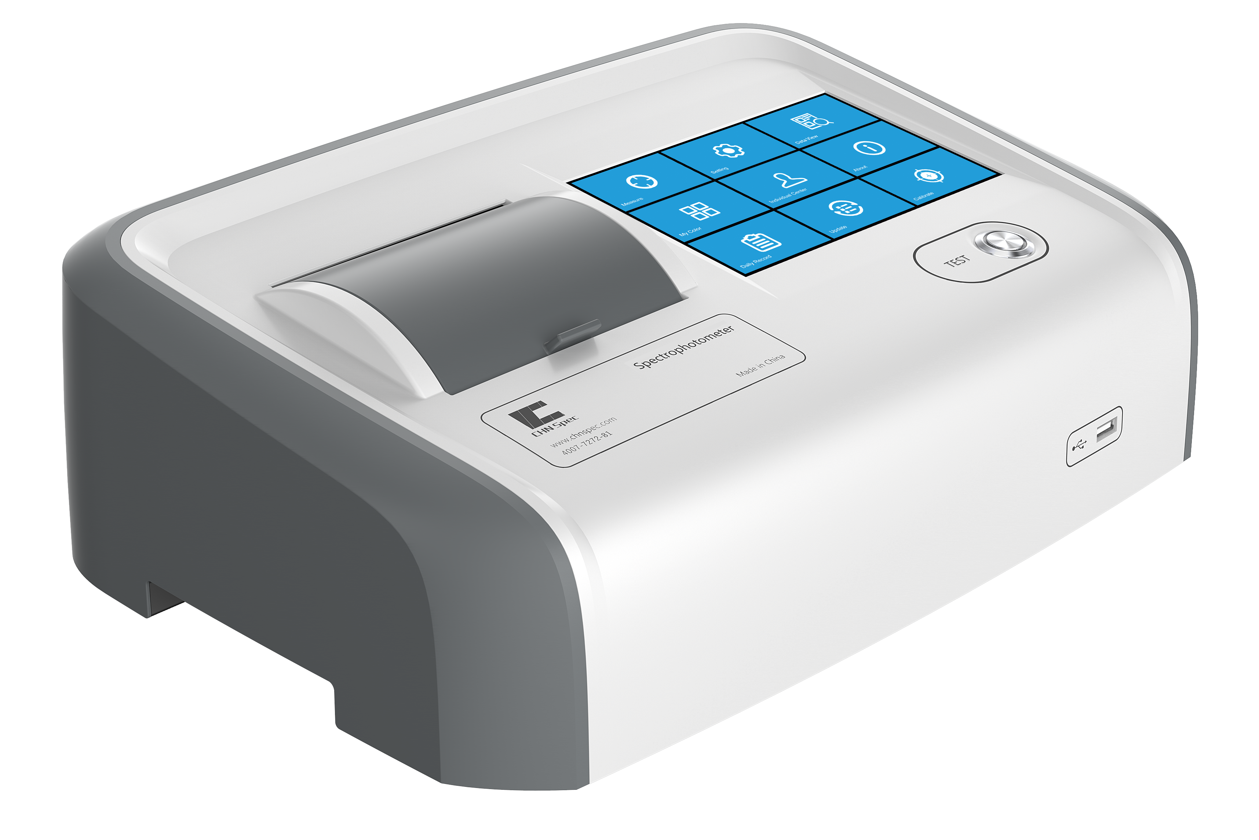

- More than 30 color indicators, including pt-co, Gardner, Saybolt, China, the United States, European Pharmacopoeia standards
- Intelligent zero calibration ensures accurate measurement of △E*ab≤0.01
- The minimum liquid addition is reduced to 1ml, 10mm and 50mm cuvette are standard, and 33mm and 100mm cuvette are optional
- Fast measurement, and a single measurement takes only 1.5 seconds
- The thermostatic sample tank (up to 90 ° C) design ensures sample fluidity
- The 7-inch touch screen make the instrument more user friendly and the instrument can store more than 100,000 pieces of data

DS-812N / DS-816N
High precision benchtop liquid Spectrophotometer

Model classification

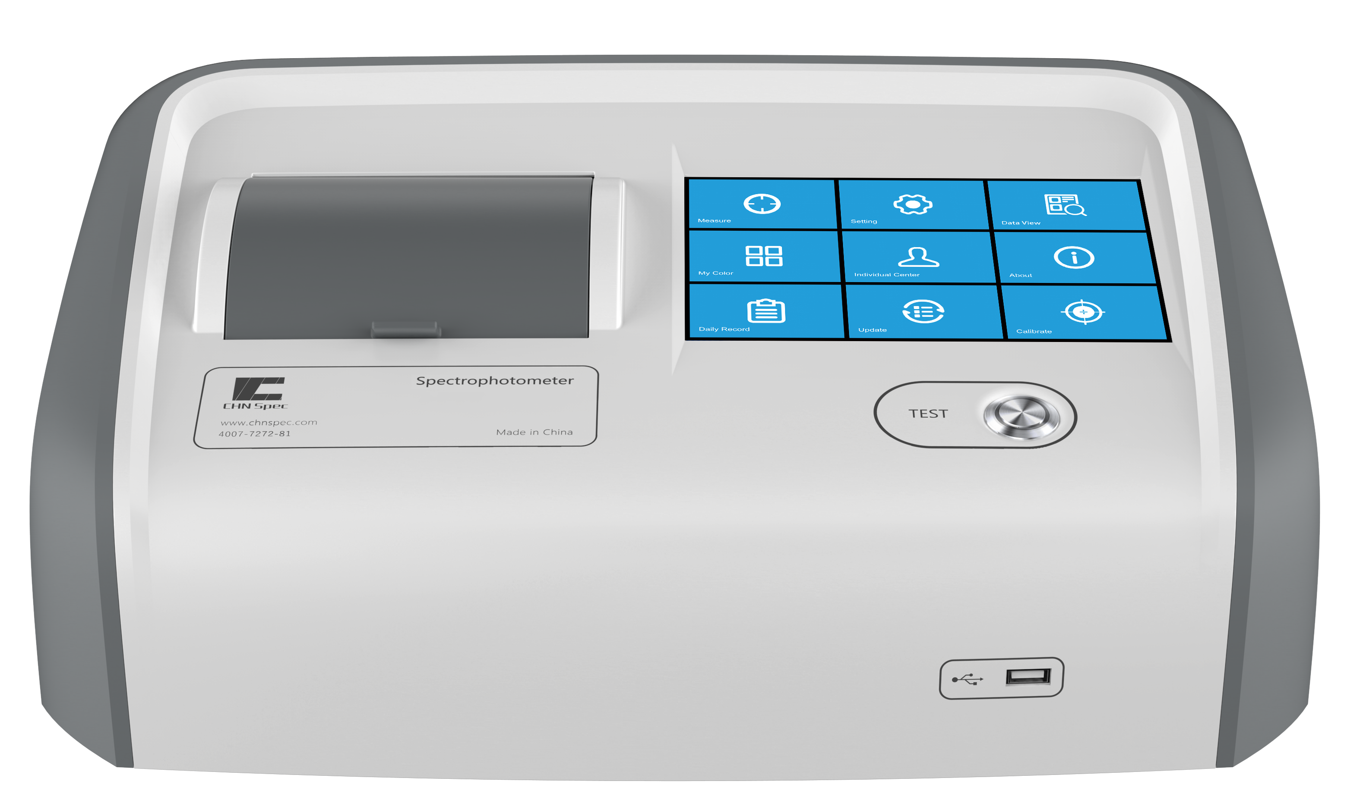
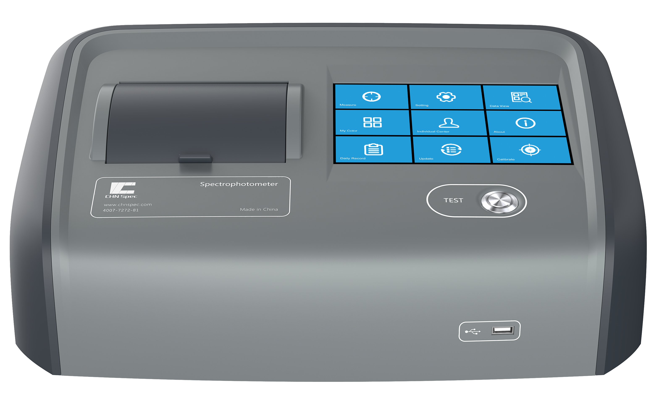

 | Benchtop Spectrophotometer DS-812N | Benchtop Spectrophotometer DS-816N
Repeatability* | ΔE*ab≤0.015 | ΔE*ab≤0.01
Inter instrument agreement | ΔE*ab ＜ 0.25 | ΔE*ab ＜ 0.2
Heating function | / | Yes
Heating temperature range | / | From ambient temperature to 90℃

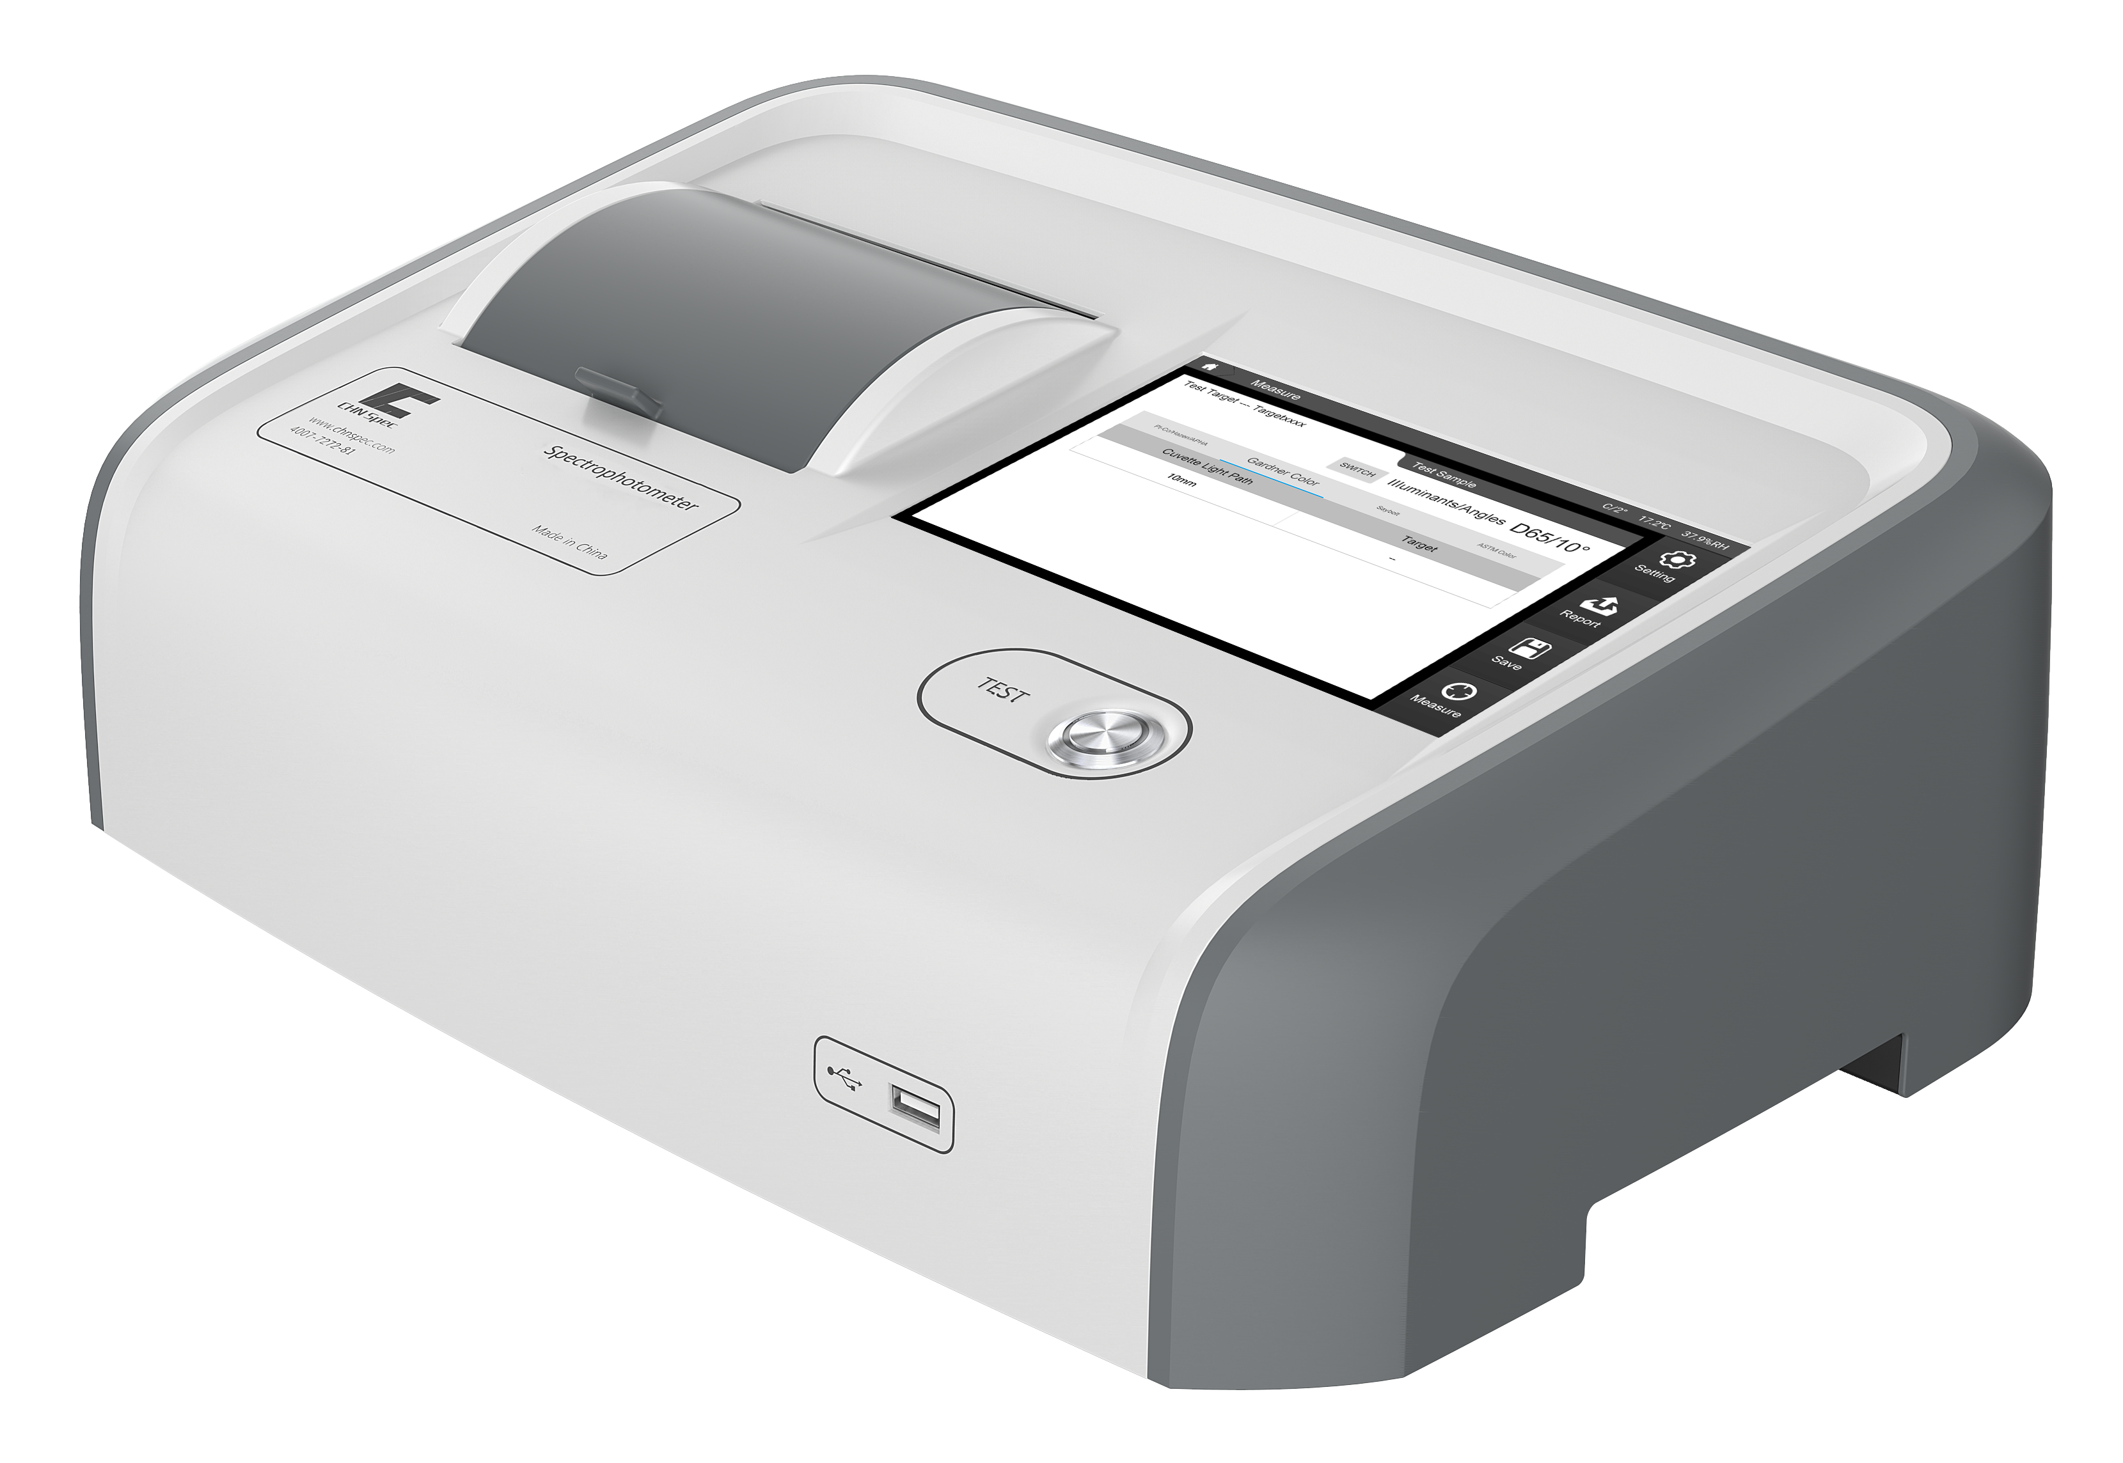

- Product characteristics
- Ultra-wide wavelength range 360-780nm
The wavelength range of the instrument is 360-780nm, which is higher than the spectral range of the human eye, extending the measurement range.
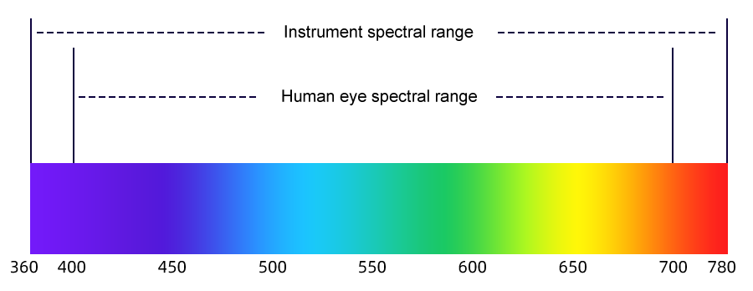


- More than 30 chroma indicators
Instrument built-in platinum cobalt, Gardner, Saybolt, Chinese Pharmacopoeia, US pharmacopoeia, European pharmacopoeia chroma and other latest indicators, products are suitable for liquid chemicals, coatings, pharmaceuticals, cosmetics, petroleum, industrial oil and other fields.

- Intelligent zero calibration technology is used to ensure data stability of 0.01
With intelligent zero calibration technology, the measurement results are stable to 0.01 repeatability even in the case of environmental changes.

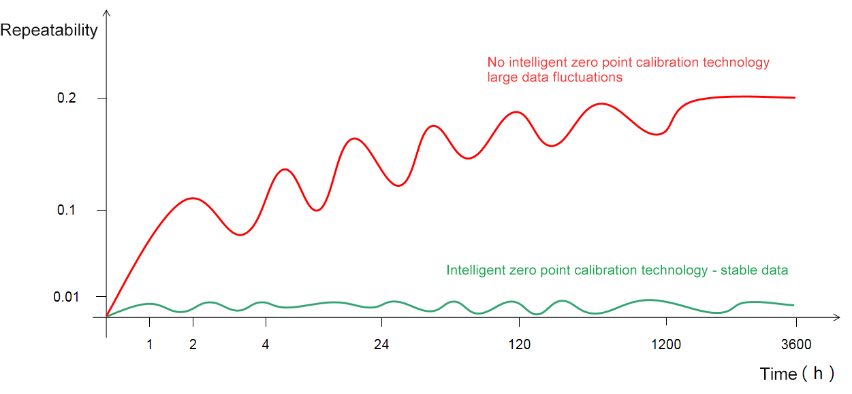

- Minimum sample request reduced to 1ml
With a more sophisticated optical design and precise control of the direction of light transmission, the minimum liquid request is reduced to 1ml, 34% less than the previous generation, saving customers expensive samples. Compatible spectrophotometer cutlery, no additional purchase or custom cutlery required.
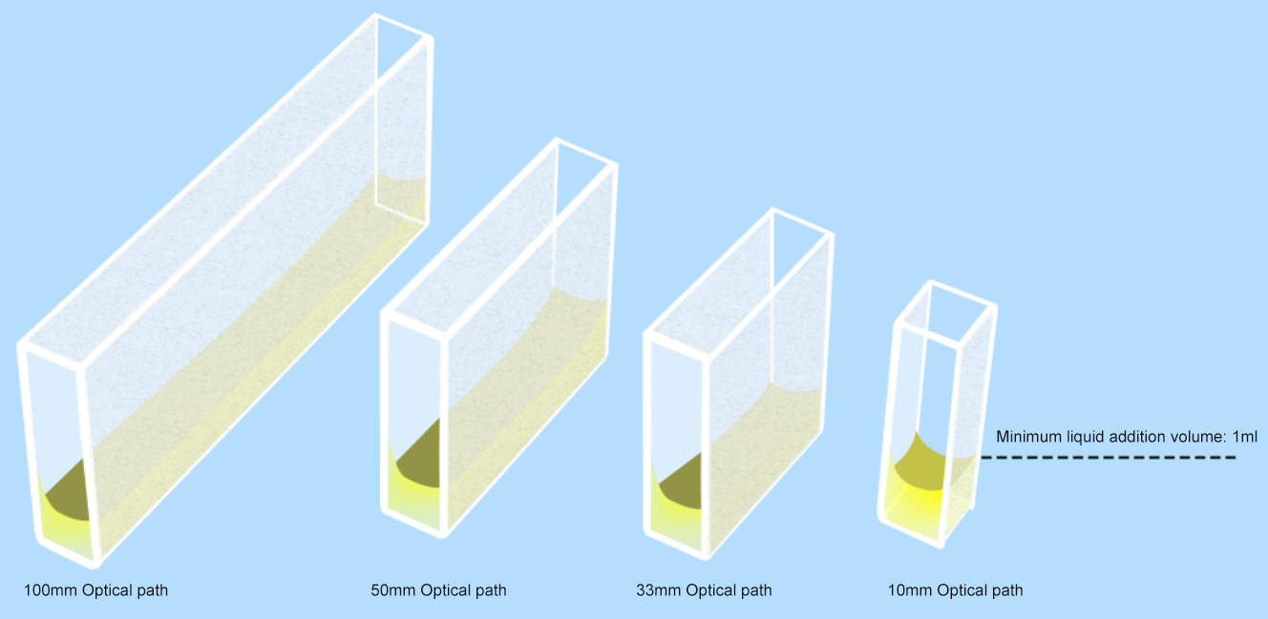

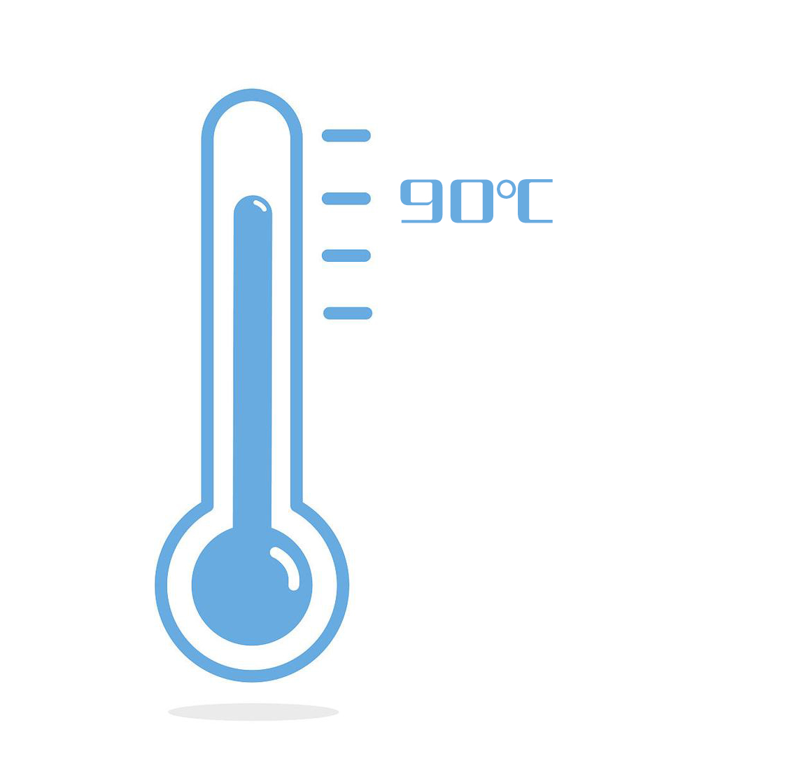

- The PTC heating module produces a constant temperature of up to 90°C
Suitable for measuring easily solidified samples such as fat and wax, it can be heated up to 90°C and maintained at temperature, so that the sample can be tested in a liquid state.

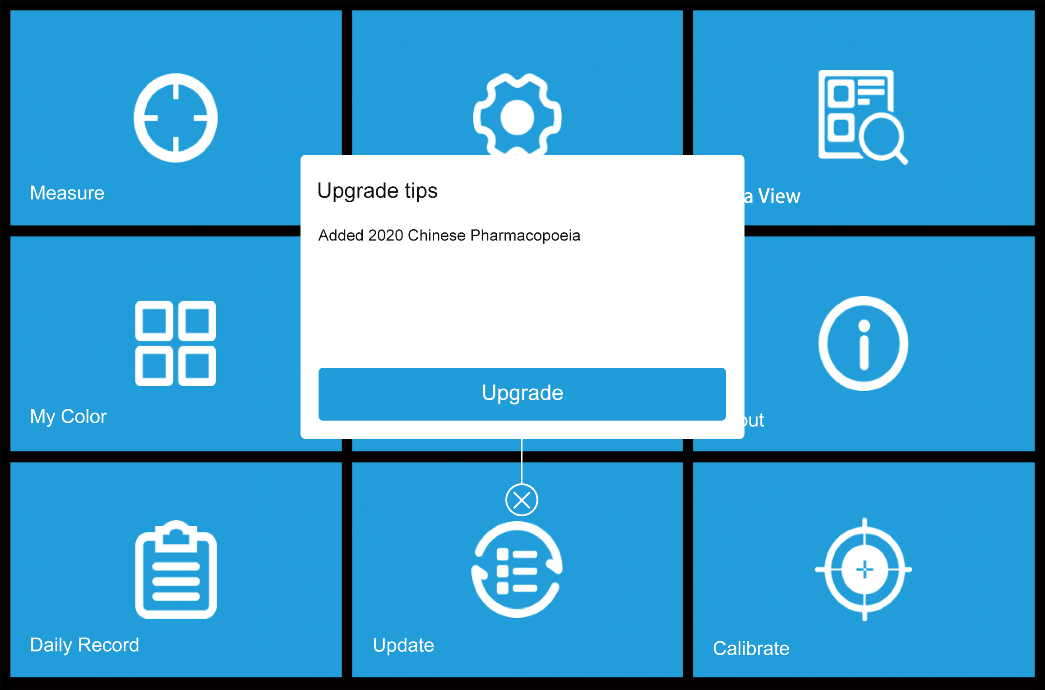
- Support OTA online upgrade to update chroma indicators and new functions at any time
Instrument support online update software function, online add measurement indicators, users can upgrade automatically obtain.

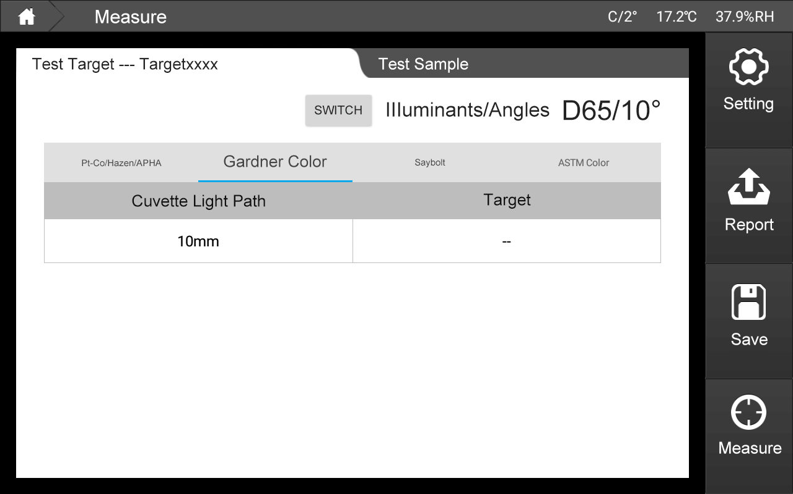
- 7 inch touch screen operation, clear display of measurement data
The instrument adopts 7 inch touch screen, supports single machine and computer operation, and can store more than 100,000 pieces of data.

- Technical parameter
Product model | DS-812N | DS-816N
Measurement condition | d/0(散射光源，0度观测角）（符合标准：CIE No.15、ISO 7724/1、ASTM E1164、DIN 5033 Teil7、JIS Z8722 Condition c、GB/T 3555、ASTM D156、GB/T 6540、ASTM D1500、ASTM D1209、ASTM D5386、ASTM D6045、ASTM D6166、ASTM D1502）
Stand-alone operation | Support
Integrating sphere | Φ40mm，Avian-D Fully diffuse surface coating
Lighting source | CLEDs(Full band balanced Led light source）
Inductor | Dual optical sensor array sensor
Wavelength range | 360-780nm
Wavelength interval | 10nm
Half-band width | 5nm
Measuring range | 0~200%
Resolution | 0.0001
Observer Angle | 2°/10°
Observation light source | A,B,C,D50,D55,D65,D75,F1,F2,F3,F4,F5,F6,F7,F8,F9,F10,F11,F12,CWF,U30,U35,DLF,NBF,TL83,TL84,ID50,ID65,LED-B1,LED-B2,LED-B3,LED-B4,LED-B5,LED-BH1,LED-RGB1,LED-V1,LED-V4
Display | Pharmacopoeia color number, transmission map/data, sample chromaticity value, color difference value/map, pass/fail result, color deviation, color simulation, historical data color simulation, manual input of standard sample, test report
Measuring time | ≤1.5s
Measuring optical path | Standard: 10mm glass cuvette, 50mm glass cuvette (optional 33mm and 100mm glass cuvette)
Color space | CIE Lab,LCh,CIE Luv,XYZ,Yxy,Transmissivity, Hunter Lab Munsell，MI,CMYK
Color difference formula | ΔE*ab,ΔE*CH,ΔE*uv,ΔE*cmc(2:1),ΔE*cmc(1:1),ΔE*94,ΔE*02
Other indicators | Pharmacopoeia (Chinese Pharmacopoeia, European Pharmacopoeia, American Pharmacopoeia)，WI(ASTM E313-20，ASTM E313-73，CIE,ISO2470/R457，Hunter，Taube Berger Stensby)，YI(ASTM D1925，ASTM E313-20，ASTM E313-73)，Tint(ASTM E313-20)，Allochromic index Milm，APHA，Hazen,Pt-Co（Platinum-cobalt index），Gardner（Gardner index），Iron cobalt index，Saybolt（Seibert index），ASTM Color，EBC（Beer color），ICUMSA Color(Sugar chroma)
Repeatability* | Transmittance: standard deviation ≤0.08%  Colorimetric value: ΔE*ab≤0.015 standard deviation, maximum ≤0.04 | Transmittance: standard deviation ≤0.08%  Chroma value: ΔE*ab≤0.01 standard deviation, maximum ≤0.03
Inter instrument agreement | ΔE*ab ＜ 0.25 | ΔE*ab ＜ 0.2
Heating function | / | Yes
Heating temperature range | / | From ambient temperature to 90℃
Audit trail | Yes (as required by FDA and CFDA)
Special function | Intelligent zero calibration
Screen size | 7 inch touch screen
Store data | Over 100,000 pieces of data
Software support | ColorExpert，Color QC2
* After correction, the standard deviation and maximum value of air are measured 30 times at an interval of 5s

- Select accessories
Material code |  | Name | Picture
3.02.41.0006-0 |  | 100mm Cuvette fixture | 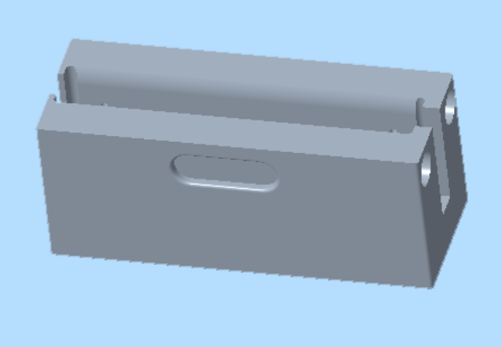
3.02.41.0000-0 |  | 100mm Cuvette heat fixture | 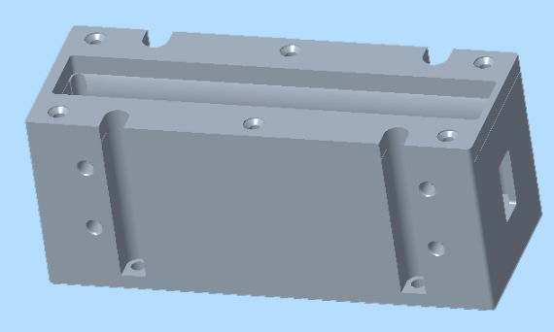
3.07.04.0012-0 |  | 100mm Cuvette | 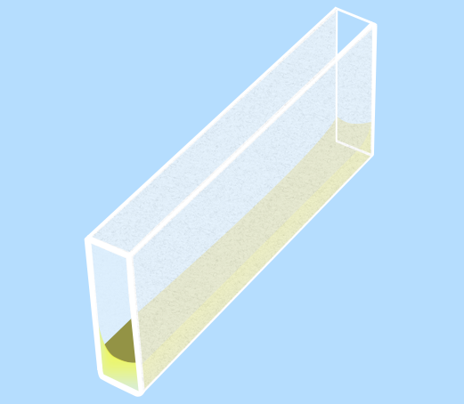
3.07.04.0010-0 |  | 50mm Cuvette | 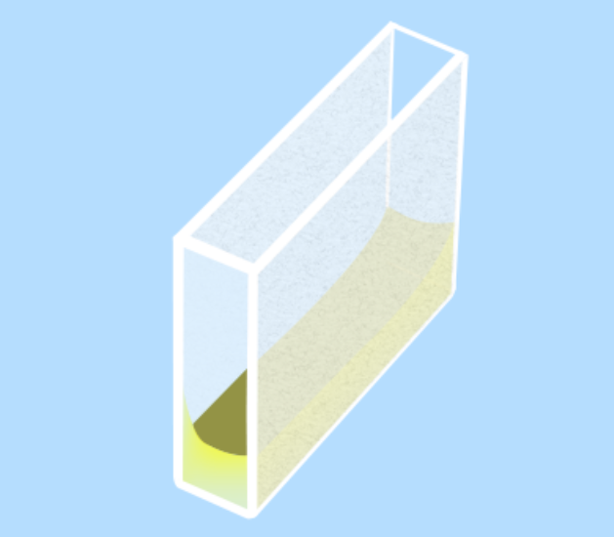
3.02.41.0004-0 |  | 33mm Cuvette fixture | 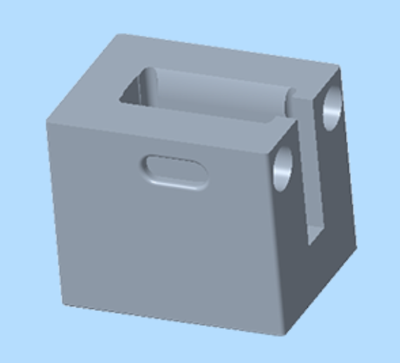
3.02.41.0001-0 |  | 33mm Cuvette heat fixture | 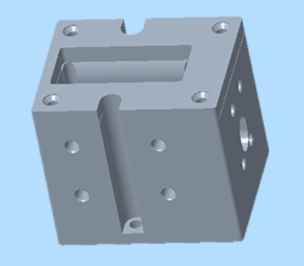
3.07.04.0011-0 |  | 33mm Cuvette | 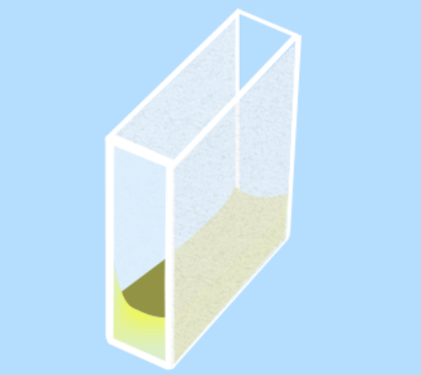
3.07.04.0009-0 |  | 10mm Cuvette | 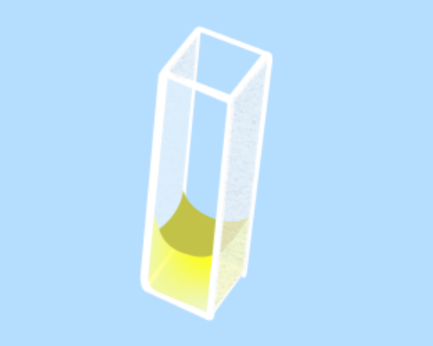

CHNSpec Technology (Zhejiang) Co., Ltd
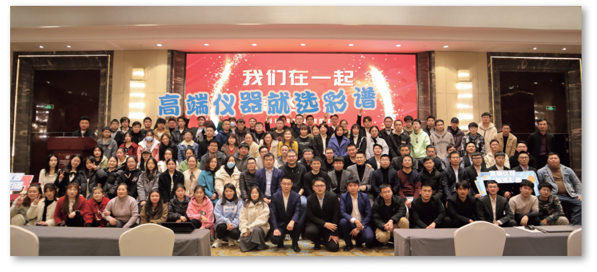
CHNSpec Technology (Zhejiang) Co., Ltd is a domestic leading enterprise in the field of color detection, mainly engaged in the research and development, production and sales of color detection equipment, products including color difference meter, spectrophotometer, transmittance fog meter, gloss meter, paint color matching software, hyperspectral camera, in domestic and foreign plastics, paint, printing, auto parts, metal, home appliances and other industries, universities, scientific research institutions are widely used. Color spectrum Technology is located in Xiasha Higher Education Park, Hangzhou. The principal person in charge of the company has a senior title and a doctorate degree or above. The company has introduced research and development teams from well-known universities such as Zhejiang University and China Jiliang University. The development of color spectrum has attracted the attention of domestic experts and scholars, and has cooperated with authoritative research institutions such as the Key Laboratory of Modern Metrology Testing and Instrumentation of Zhejiang Province and the National Engineering Center of Metrology Testing Technology of the Ministry of Education. Under the care of experts, the technical level and research and development ability of color spectrum have been developed by leaps and bounds, and have achieved remarkable results. Color spectrum technology has a number of invention patents, including the United States invention patent 1, a number of utility model patents, appearance patents, software Copyrights. In addition, there are a number of invention patents in the announcement stage. Many papers published by color spectrum technology were published in domestic first-class scientific research journals, and were included by SCI and EI.
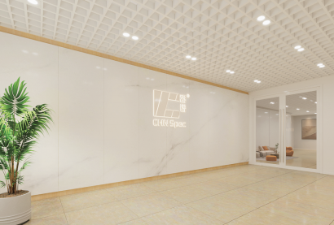

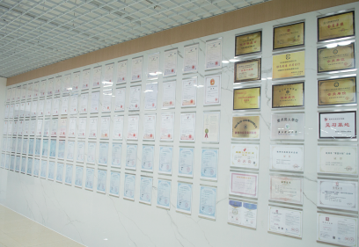

CHNSpec Technology (Zhejiang）Co.,Ltd

CHNSpec Technology (Zhejiang）Co.,Ltd

Qualification and honor
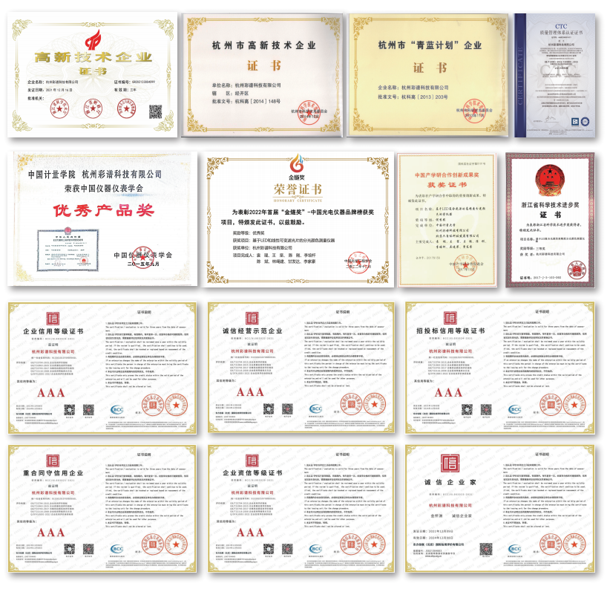
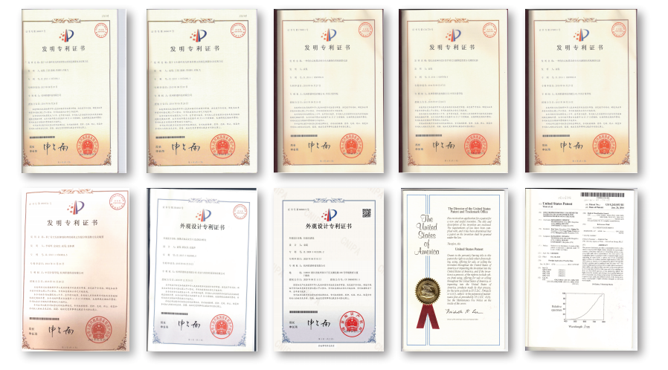

CHNSpec Technology (Zhejiang）Co.,Ltd

Product certificate
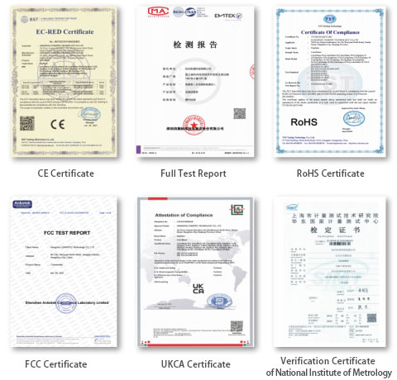
CHNSpec Technology (Zhejiang）Co.,Ltd

Participation in standard development
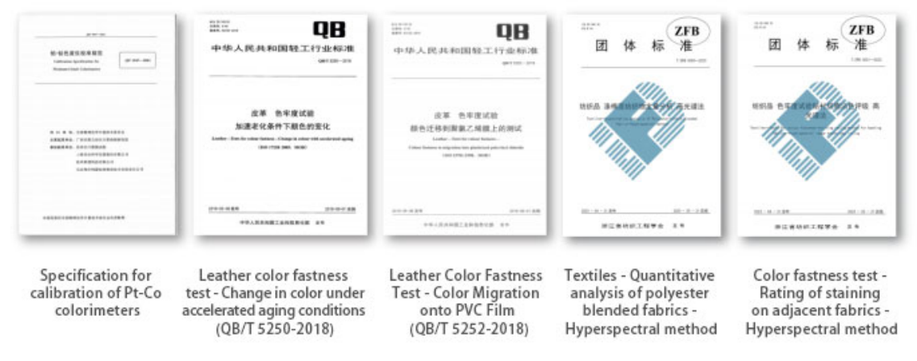

Industry conference
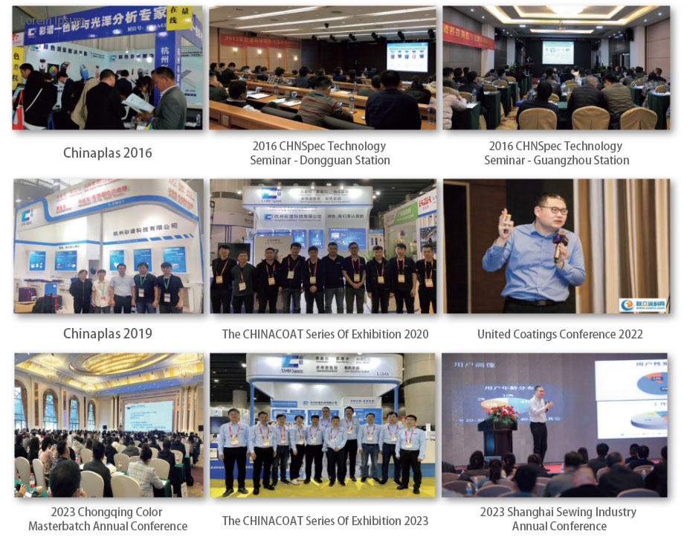

CHNSpec Technology (Zhejiang）Co.,Ltd

