**Product model**

**DS60**

**DS62**

**DS64**

**Highly cost-effective portable spectrophotometer**



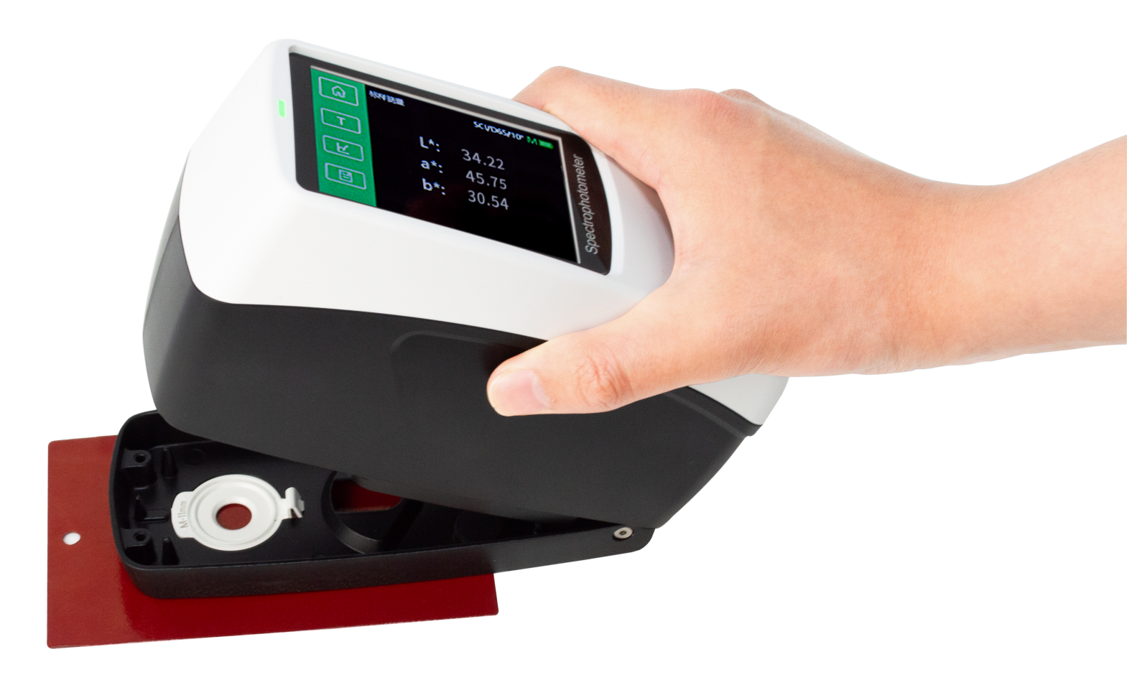

* Ultra-high repeatability accuracy：dE*ab≤0.02
* Horizontal compression measurement, physical positioning observation window
* More than 30 measurement parameters and nearly 40 evaluation light sources
* Supports 5 measurement calibers to meet users’ measurement

scenarios of different sample sizes

* The software supports WeChat applet, Android, Apple, Hongmeng,

mobile APP, etc., and supports data synchronization

1. **Product features**

* **Horizontal compression measurement, physical positioning observation window**
* The DS60 series spectrophotometer adopts a horizontal

design with a low center of gravity, which can be

stableMeasure the surface being measured. During the

measurement process, you can follow the observation

windowCheck the measurement position at all times to

avoid measurement position errors.

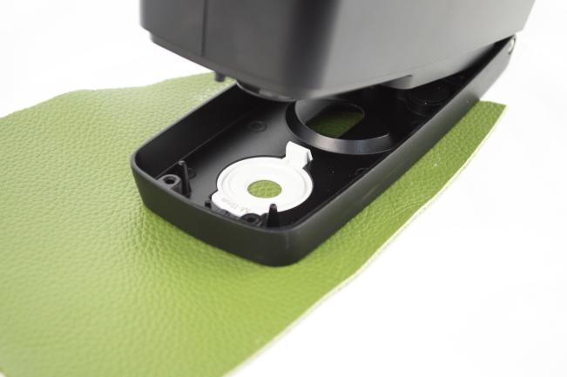

* **Ultra-high repeatability accuracy：dE*ab**

**≤0.02**

* Repeatability accuracy is the most important indicator

to describe the performance of a spectrophotometer.

The DS60 series spectrophotometer adopts

high-precision nanometer spectroscopic devices, which enables the repeatability accuracy of the instrument to reach a level of dE*ab≤0.02 that is difficult to match with similar products.

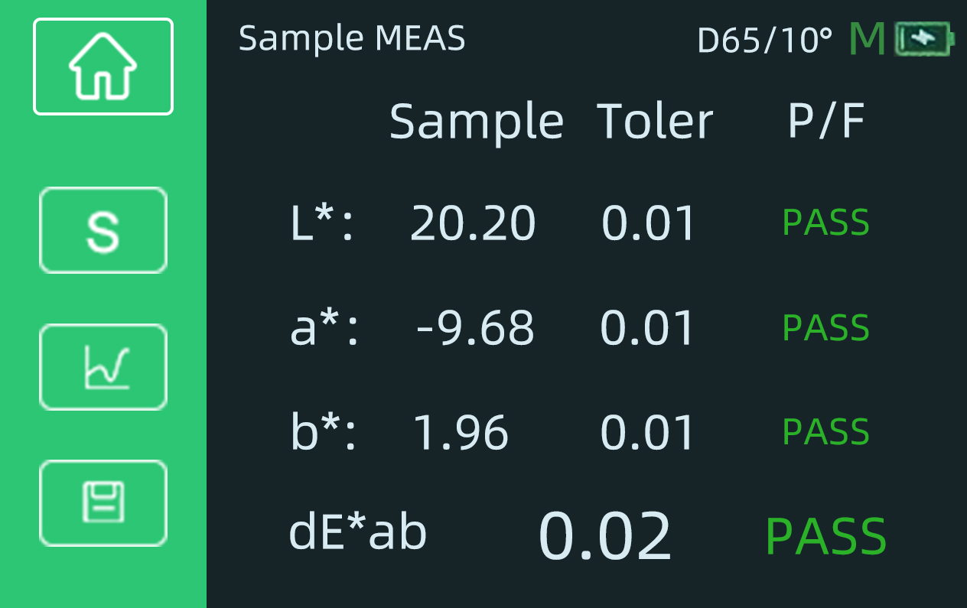

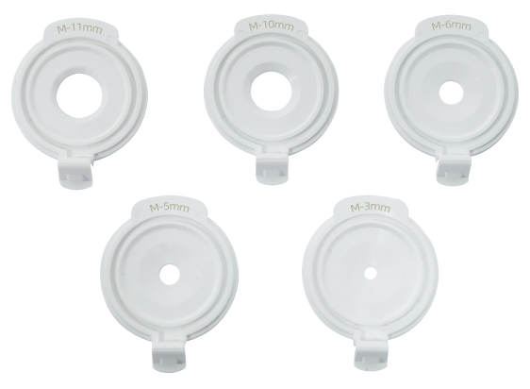

* **DS60 series supports 5 measurement calibers**
* In order to facilitate users to measure samples of

different sizes, the DS60 series is divided into The optical colorimeter supports 5 calibers for customers to use: Φ11mm, Φ10mm,Φ6mm, Φ5mm, Φ3mm, can be flexibly applied to various samples products and test conditions.

* **More than 30 measurement parameters and nearly 40 evaluation light sources**
* DS60 series spectrophotometers provide spectral

reflectance, CIE-Lab, CIE-LCh,ΔE*ab, covering power, whiteness, yellowness and other 30+ measurement indicators; A, B, C,There are nearly 40 evaluation light sources to choose from such as D50, D55, and D65, covering almost all industries All color measurement metrics and light source types included.

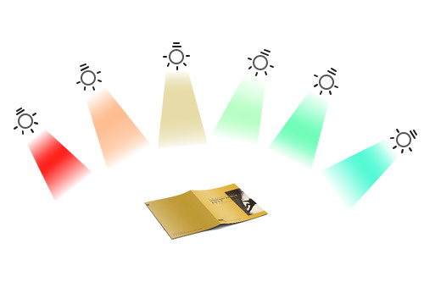

* **Support WeChat applet, Android, Apple, Hongmeng, mobile APP**
* The DS60 series spectrophotometer can be connected to various mobile

phones through a variety of mobile programs.

* Users no longer need to transmit the color values and physical objects of

samples, but can easily transmit color data through WeChat.

* Users can search for the closest color among multiple sets of color cards
* Users can create a personal color database and enter color card

information for printing, coatings, textiles, etc. The created color library

can be uploaded to the cloud for multi-device data sharing, making

color processing more convenient.

* Enterprise users can create and manage their own color card

information library and color formulas in the cloud, and share the

information library and color formulas with their own users through

unique invitation codes.

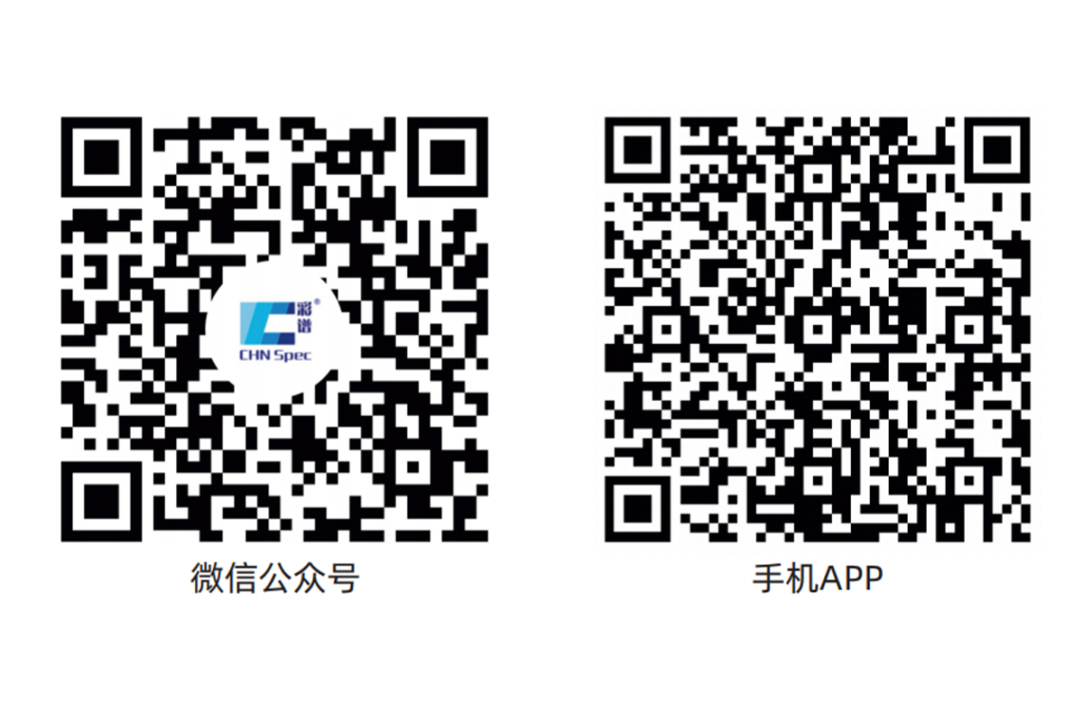

微信小程序



* **Use the powerful PC-side color management system ColorExpert**

The DS60 series spectrophotometer comes with the Windows color management system ColorExpert, which can be connected to the DS60 series spectrophotometer via Bluetooth or USB cable. ColorExpert is a full-featured color management software with four major functional modules: My Color, Color Detection, Color Matching System, and Personal Center.

1. In the "My Colors" function module, users can collect or create new color libraries they need among

hundreds of color libraries shared by other users. Electricity The brain software and mobile APP can share an account, and the color library data follows the account to achieve information synchronization between PC and mobile terminals.

1. In the "Color Detection" function module, users can calibrate, measure, and set up the

spectrophotometer through computer software. Users can use the colors in the cloud database as standard samples to measure color differences, view spectra, color difference charts, standard sample data, and export the desired data test report.

1. In the "Color Matching System" function module, it can provide users with a more convenient and

efficient color matching process. After the instrument measures the color of the sample, the system calculates the formula in the formula center and automatically corrects the color, finally achieving an accurate match. Suitable for computer automatic color matching applications in paints, coatings, printing, textiles and other fields.

1. In the "Personal Center" function module, users can edit their personal information, search or delete

connected instrument information, manage downstream users, and manage color libraries shared with downstream users.

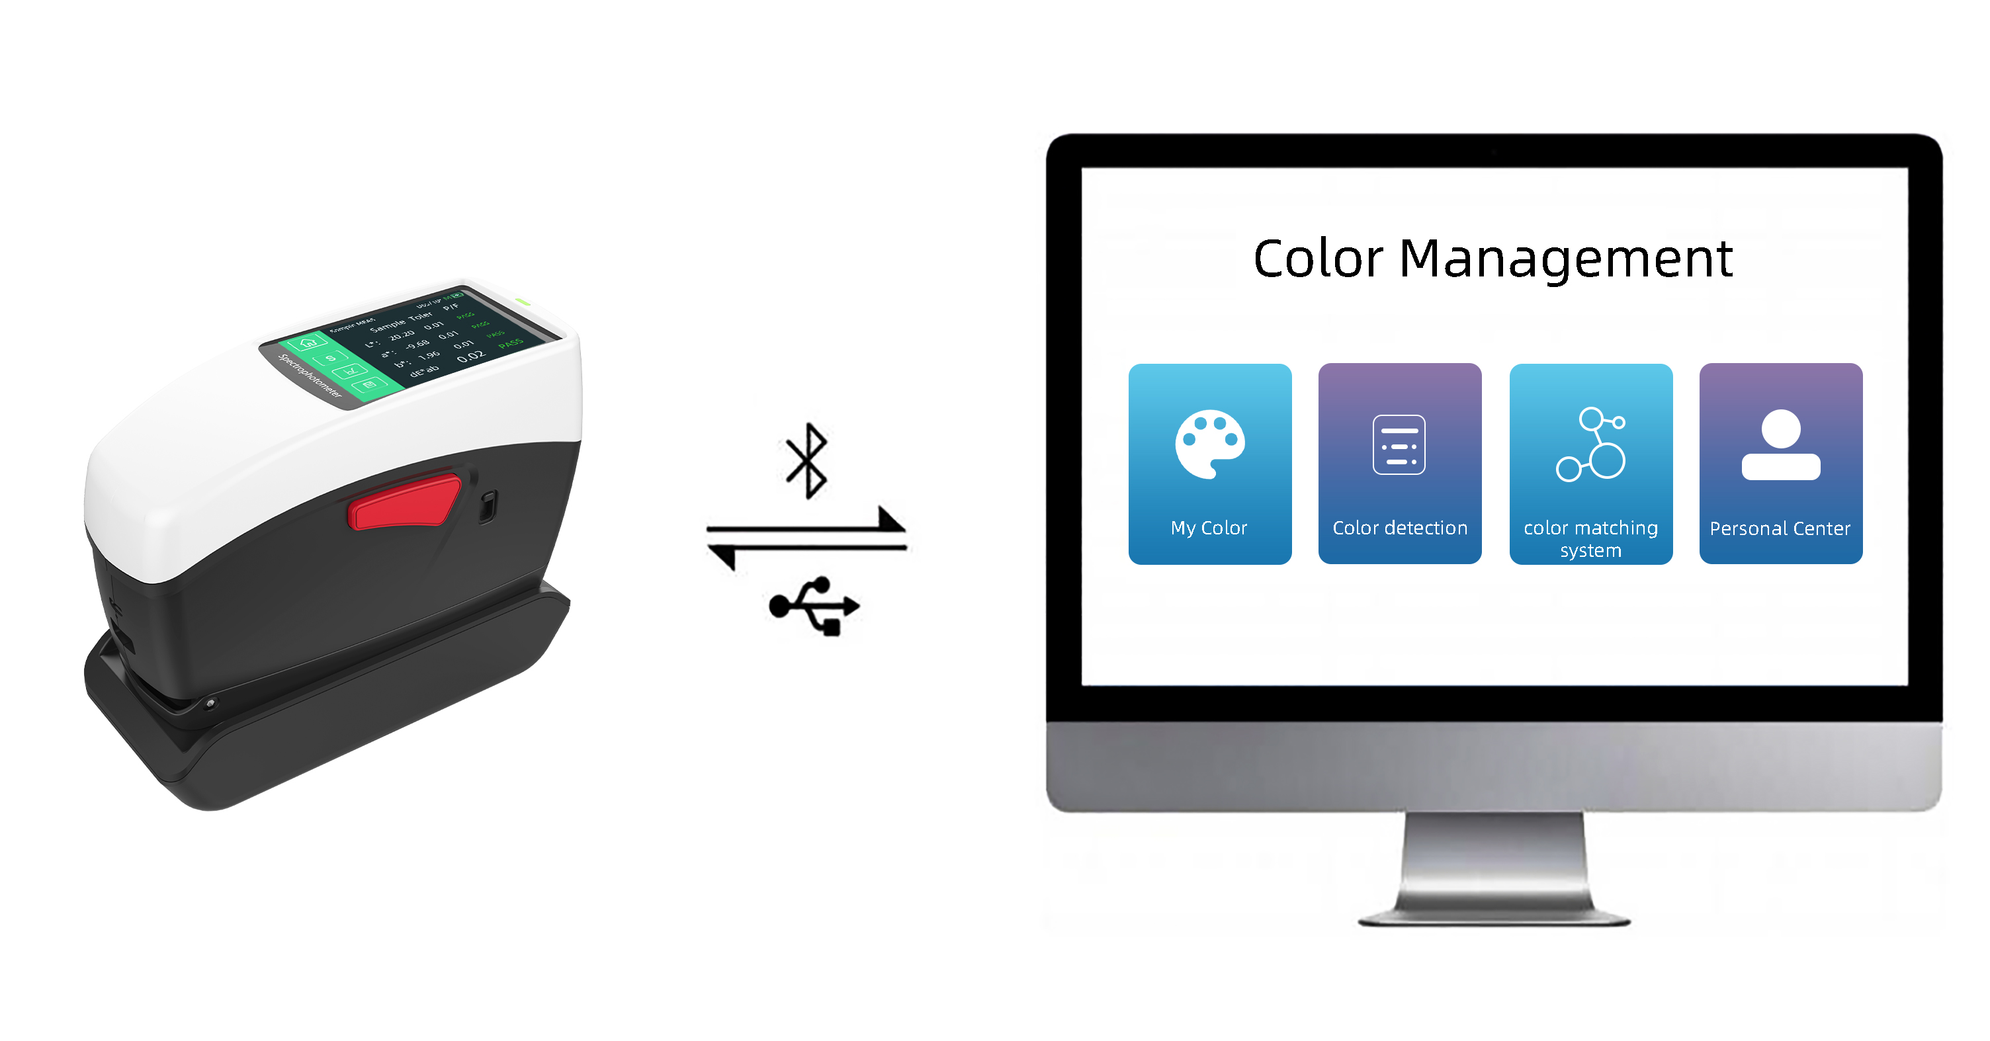

1. **Brief table of model distinctions**

|  |  |  |  |
| --- | --- | --- | --- |
| Model | DS60 | DS62 | DS64 |
| SCI/SCE simultaneous measurement | ● | ● | ● |
| Measurement repeatability | dE*ab≤0.02 | | |
| caliber | Φ11mm | Φ11mm,Φ6mm,Φ3mm | Φ11mm,Φ10mm,Φ6mm,  Φ5mm,Φ3mm |
| UV | / | ● | ● |
| Integrated physical positioning holes | ● | ● | ● |
| NetProf network calibration | / | / | ● |

1. **Product parameters**

|  |  |  |  |
| --- | --- | --- | --- |
| Model | DS60 | DS62 | DS64 |
| Measuring structure※ | D/8,SCI+SCE | | |
| SCI+SCE simultaneous measurement | support | | |
| NetProf network calibration | / | / | support |
| Integrated physical positioning holes | support | | |
| Measurement repeatability※※ | dE*ab≤0.02 | | |
| Display accuracy | 0.01 | | |
| lighting source | Full-band balanced LED light source | | |
| UV light source | / | support | |
| caliber | Φ11mm | Φ11mm,Φ6mm,Φ3mm | Φ11mm,Φ10mm,Φ6mm,  Φ5mm,Φ3mm |
| measurement standard | Spectral reflectance, CIE-Lab, CIE-LCh, HunterLab, CIE-Luv, XYZ, Yxy, RGB color difference (ΔE*ab, ΔE*cmc, ΔE*94, ΔE*00), whiteness (ASTME313-00, ASTME313 -73, CIE, ISO2470/R457, AATCC, Hunter, TaubeBerger Stensby) yellowness (ASTM D1925, ASTM E313-00, ASTM E313-73) blackness (My, dM), stain fastness, color fastness, Tint (ASTM E313-00) Color density CMYK (A, T, E, M), metamerism index Milm, Munsell, hiding power, strength (dye strength, tinting strength) | | |
| Light source conditions | A,B,C,D50,D55,D65,D75F1,F2,F3,F4,F5,F6,F7,F8,F9,F10,F11,F12CWF,U30,U35,DLF,NBF,TL83,TL84,ID50,ID65,LED-B1,LED-B2,LED-B3,LED-B4LED-B5,LED-BH1,LED-RGB1,LED-V1,LED-V2 | | |
| software support | Android, iOS, Windows, WeChat applet, Hongmeng | | |
| Accuracy guaranteed | Ensure measurement is qualified | | |
| field of view | 2°，10° | | |
| Integrating sphere diameter | 40mm | | |
| follow standards | CIENo.15,GB/T3978,GB2893,GB/T18833,ISO7724-1,ASTME1164,DIN5033Teil7 | | |
| Spectral method | High-precision nano spectroscopic device | | |
| sensor | Silicon photodiode array dual 16 groups | | |
| Wavelength interval | 10nm | | |
| Wavelength range | 400-700nm | | |
| Reflectivity measurement range | 0-200% | | |
| Reflectance resolution | 0.01% | | |
| measure time | about 1 s | | |
| interface | USB, Bluetooth | | |
| Screen | Full color screen, 3.5 inches | | |
| battery capacity | Can continuously measure 8000 times on a single charge, 7.2V/3000mAh | | |
| Light source life | 5 million times | | |
| language | Simplified Chinese, English | | |
| storage | Instrument: 10,000 items; APP: Mass storage | | |

|  |
| --- |
|  |

※Diffuse illumination/8° direction reception, including specular reflected light/removing specular reflected light

※※After the whiteboard is calibrated, measure the whiteboard 30 times at 5-second intervals and measure the standard deviation of the results using the MAV caliber.

※Diffuse illumination/8° direction reception, including specular reflected light/removing specular reflected light

※※After the whiteboard is calibrated, measure the whiteboard 30 times at 5-second intervals and measure the standard deviation of the results using the MAV caliber.



**CHNSpec Technology (Zhejiang) Co., Ltd**

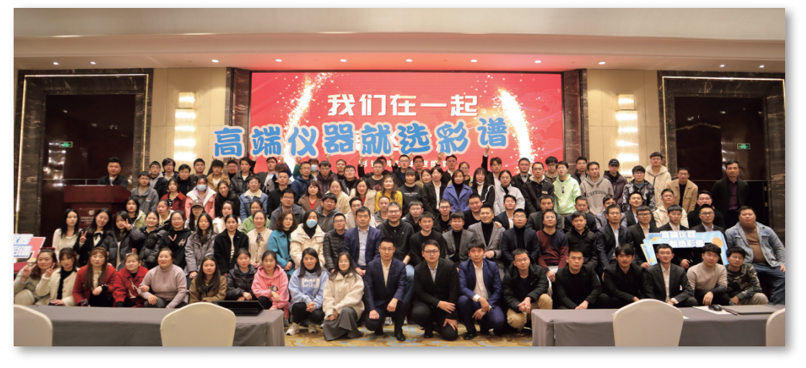

CHNSpec Technology (Zhejiang) Co., Ltd is a domestic leading enterprise in the field of color detection, mainly engaged in the research and development, production and sales of color detection equipment, products including color difference meter, spectrophotometer, transmittance fog meter, gloss meter, paint color matching software, hyperspectral camera, in domestic and foreign plastics, paint, printing, auto parts, metal, home appliances and other industries, universities, scientific research institutions are widely used. Color spectrum Technology is located in Xiasha Higher Education Park, Hangzhou. The principal person in charge of the company has a senior title and a doctorate degree or above. The company has introduced research and development teams from well-known universities such as Zhejiang University and China Jiliang University. The development of color spectrum has attracted the attention of domestic experts and scholars, and has cooperated with authoritative research institutions such as the Key Laboratory of Modern Metrology Testing and Instrumentation of Zhejiang Province and the National Engineering Center of Metrology Testing Technology of the Ministry of Education. Under the care of experts, the technical level and research and development ability of color spectrum have been developed by leaps and bounds, and have achieved remarkable results. Color spectrum technology has a number of invention patents, including the United States invention patent 1, a number of utility model patents, appearance patents, software Copyrights. In addition, there are a number of invention patents in the announcement stage. Many papers published by color spectrum technology were published in domestic first-class scientific research journals, and were included by SCI and EI.

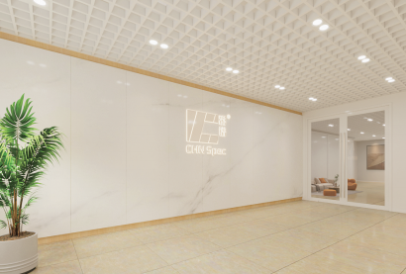

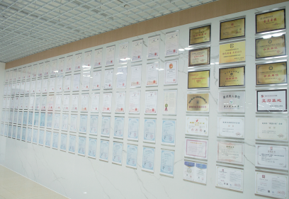

CHNSpec Technology (Zhejiang）Co.,Ltd



CHNSpec Technology (Zhejiang）Co.,Ltd

**Qualification and honor**

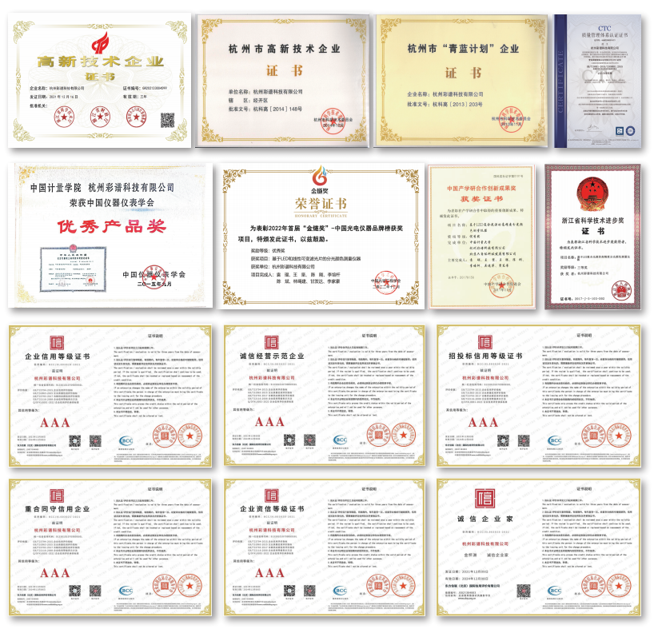

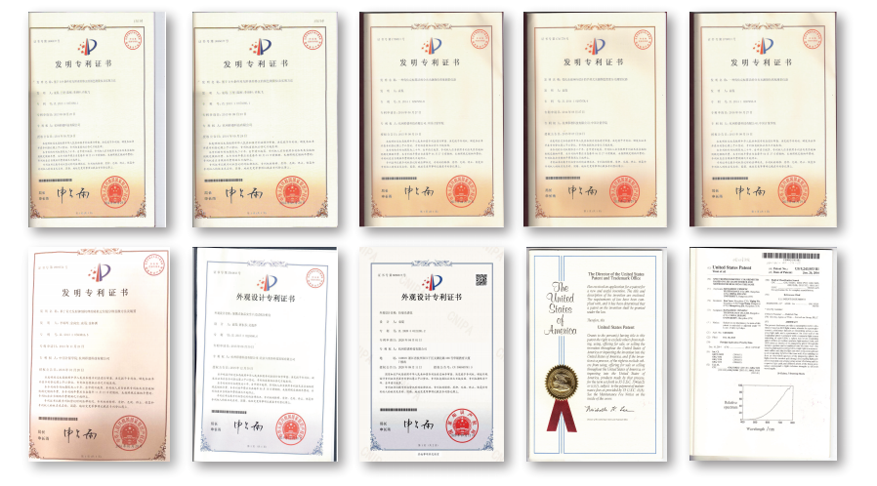



CHNSpec Technology (Zhejiang）Co.,Ltd

**Product certificate**

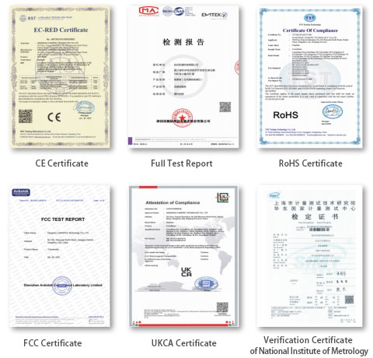

CHNSpec Technology (Zhejiang）Co.,Ltd

**Participation in standard development**

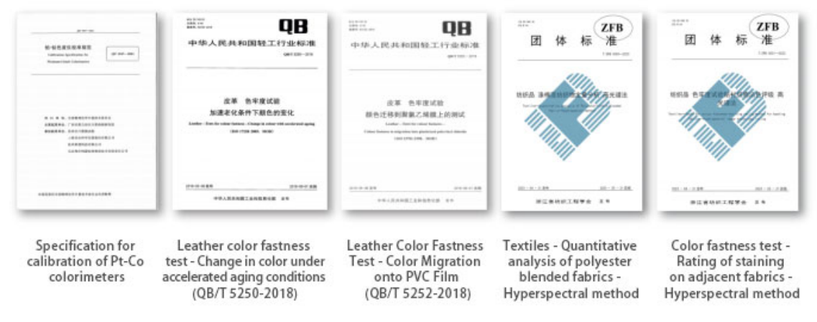

**Industry conference**

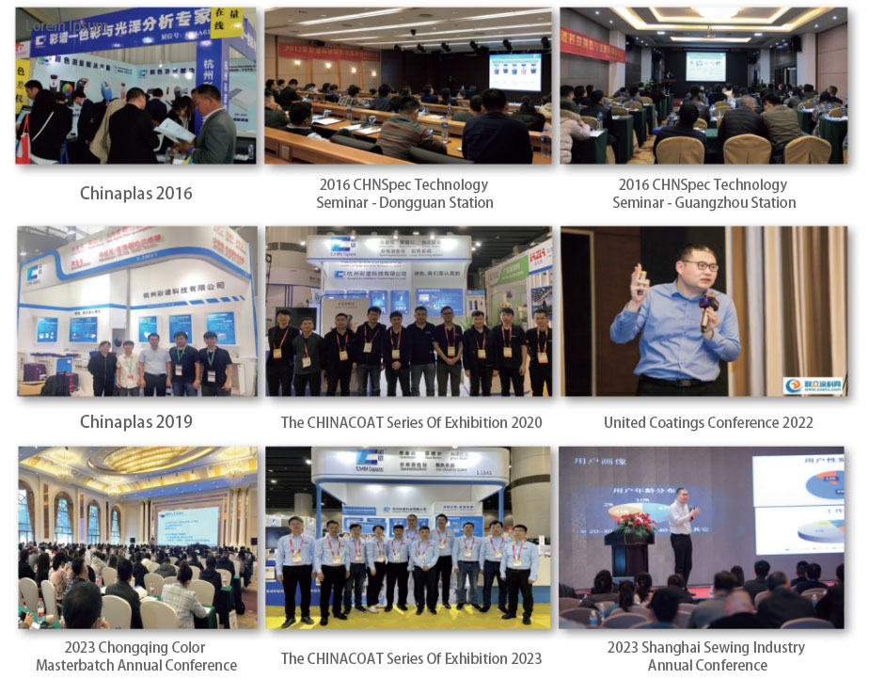

CHNSpec Technology (Zhejiang）Co.,Ltd