**Colorimeter DS-200 series**

Stable and reliable instrument for color difference detection Repeatability accuracy is up to: dE\*ab < 0.03

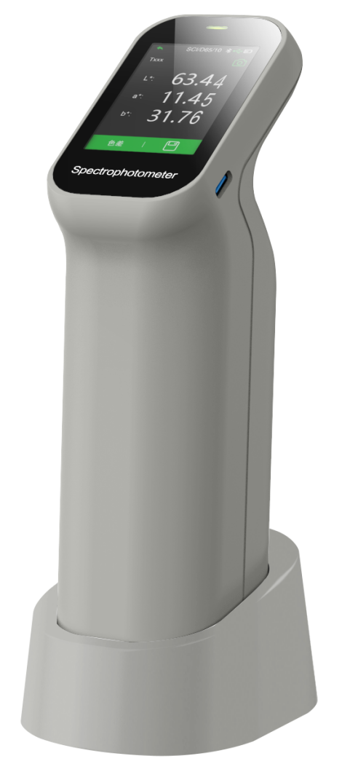

Ⅰ、Key technology

1. Dual optical path design improves repeatability accuracy dE\*ab≤0.03

The dual optical path design monitors light source energy fluctuations while measuring the sample signal, reducing interference during measurement, obtaining higher measurement stability and improving the instrument's measurement repeatability index to dE\*ab ≤ 0.03, which guaranteed the measuring speed, accuracy and stability of the instrument. Related technologies are protected by Chinese invention patents and US invention patents.

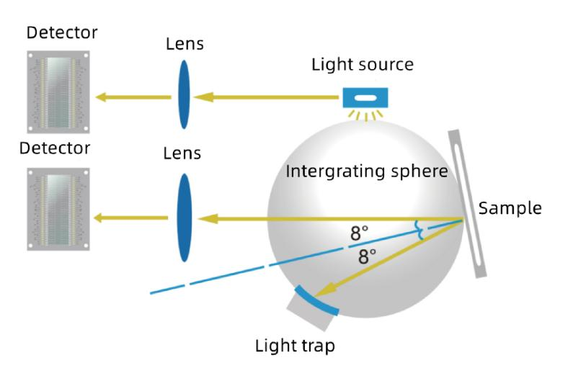

1. Innovative 5 micron thick nano-integrated optics

After intensive research, using nano-integrated optical devices as light splitters, only 5 micron thick optical devices can achieve nano-level light splitting ability, once again leading the direction of industry innovation, greatly improving the technical performance of products. Relevant technologies are protected by Chinese invention patents.

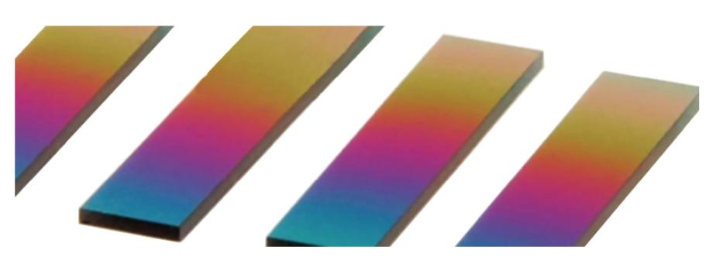

Ⅱ、Product features

1. Over 30 Measurement Indicators

• RGB,Lab,Reflectance,LCh,Hunter Lab,CIE-Luv,XYZ,Yxy

• Difference(ΔE\*ab,ΔE\*cmc,ΔE\*94,ΔE\*00)

• WI(ASTM E313-00,ASTM E313-73,CIE/ISO,AATCC,Hunter,Taube Berger Stensby)

• YI(ASTM D1925,ASTM E313-00,ASTM E313-73)

• Blackness(My,dM),Color Fastness,Tint(ASTM E313-00)

• Color Density CMYK(A,T,E,M), Milm, Munsell, Opacity, Color strength

1. Evaluate whether the color is jumping light, and provide nearly 40 evaluation light sources

A, B, C, D50, D55, D65 and nearly 40 evaluation light sources can be selected, covering almost all the color measurement indicators and light source types in the industry.

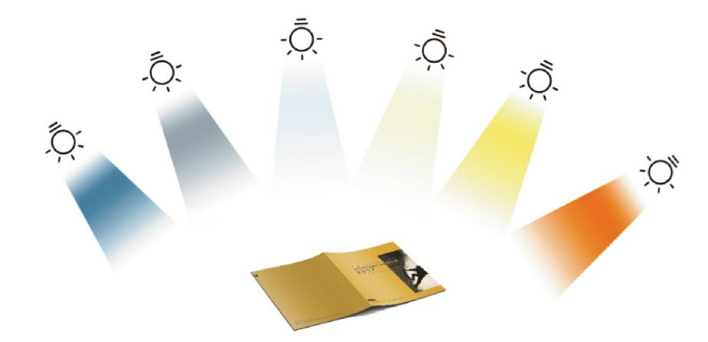

1. Contains SCI measurement mode

SCI refers to specular reflections that are generally used to study the properties of a color itself without regard to the surface gloss of the sample to which it is attached.

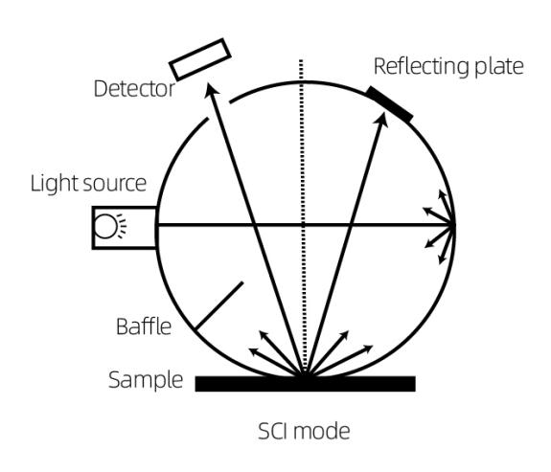

1. Contains UV for fluorescent color measurement

DS-200 series colorimeter still provide stable and objective reflectivity data for color measurement on surfaces containing fluorescent materials.

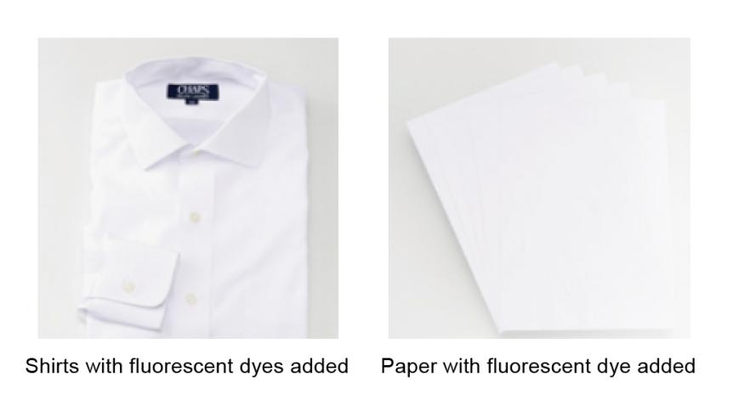

1. Calibration base and zirconium reference with a Mohs hardness of 9 to calibrate the instrument, ensuring long-term stability

Compared to existing products, the DS-200 series spectrophotometer does not require frequent manual calibration when in use. Simply place it on the calibration base and the instrument will automatically calibrate the overall instrument function and accuracy according to its own state and environmental factors, ensuring that the instrument is always in a stable state and ready for use.

The white plate in the calibration base is the basis of the instrument's work. Through long-term investment and research, CHNSpec has integrated zirconium material as the calibration white plate, with a Mohs hardness of 9. As the material itself has the hardness and stability comparable to diamond, the surface of the calibration white plate will not be scratched and will not change colour with changes in temperature and humidity. This is a further improvement in the stability and durability of the calibration whiteboard compared to similar foreign and domestic products that use common industrial ceramics or even plastic as calibration whiteboards, ensuring the performance of the instrument.

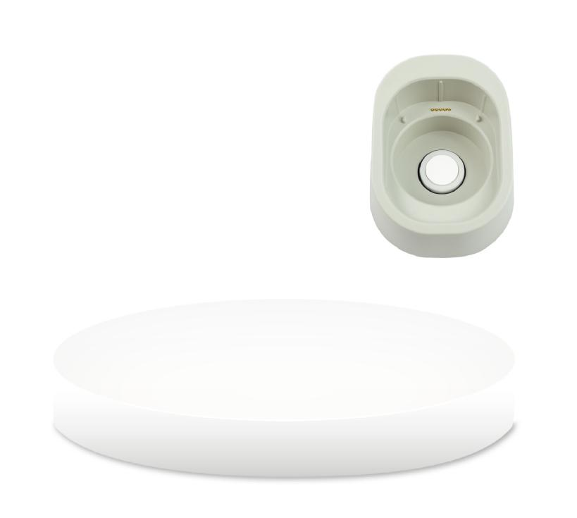

Calibrated white plate

(artificial diamond zirconium material)

·Mohs hardness: 9

·Spectral reflectance >90%

·No discolouration due to changes in

temperature and humidity

·No discolouration by oxidation

·Ultra-high strength without scratching

1. The DS-200 series supports 6 measuring apertures for selection（11mm，6mm，3mm）

Rotate to switch the caliber. Say goodbye to the tedious manual screw fixing method.

Stable type：Φ11mm，Φ6mm，Φ3mm

Dexterous type：▽11mm，▽6mm，▽3mm

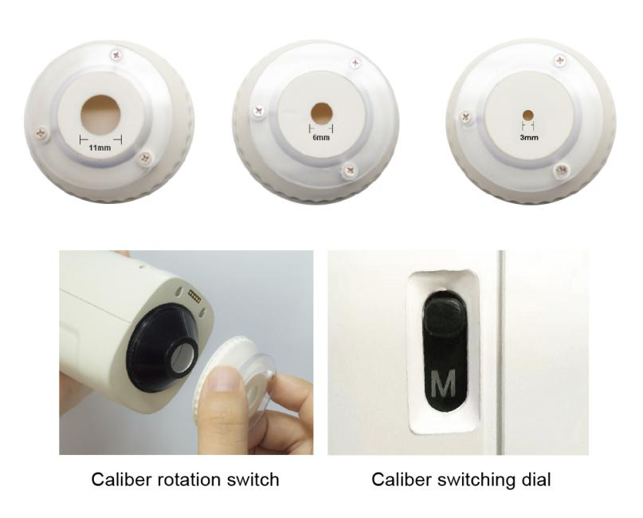

1. Built-in HD camera for clear observation of the measured area

DS-200 series spectrophotometer can obtain an image of the measured area through the camera when measuring, which can clearly locate the measured area of the sample and avoid inaccurate measurement due to wrong area.

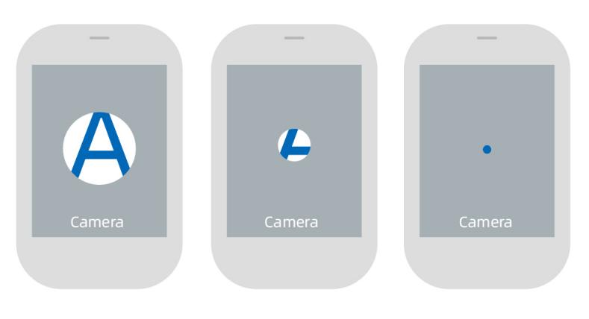

1. Support WeChat applet, Android, Apple, Hongmeng mobile APP

• The DS-200 series colorimeter can be connected to a variety of mobile phones via a rich mobile app.

• Users no longer have to pass on the colour values of samples and physical objects, they can easily pass on colour data via WeChat.

• Users can find the most similar colours in multiple sets of colour cards.

•Users can create personal colour databases and enter information on colour cards for printing, paint and textiles. The colour libraries created can be uploaded to the cloud for easy colour processing with data sharing across multiple devices.

• Business users can create and manage their own colour card information library and colour recipes in the cloud, and share the information library and colour recipes to their own users through a unique invitation code.

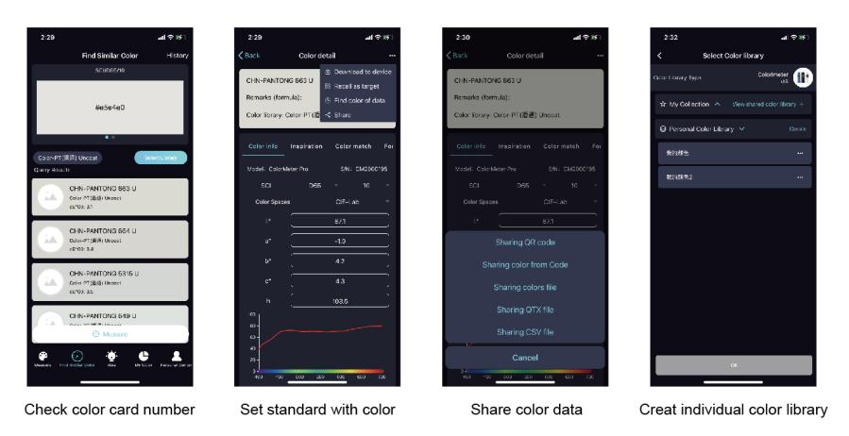

1. Use the powerful PC-based colour management system ColorExpert

The Windows color management system ColorExpert is included in the DS-200 series colorimeter package, which can be connected to the colorimeter through Bluetooth or USB cable.

ColorExpert is a full-featured colour management software with four functional modules: My Colours, Colour Check, Colour Matching System and Personal Centre.

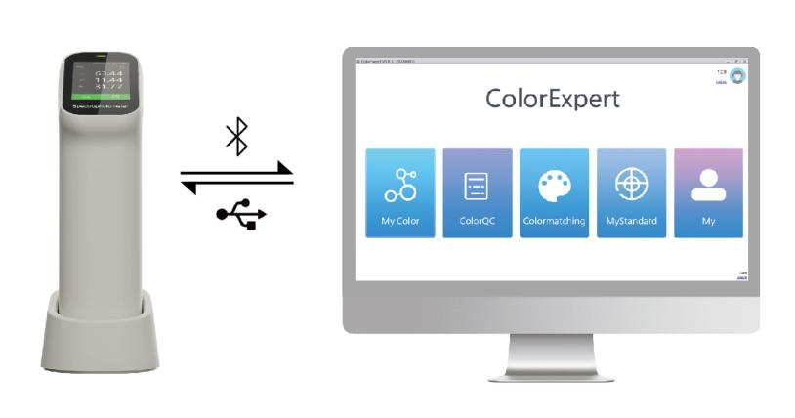

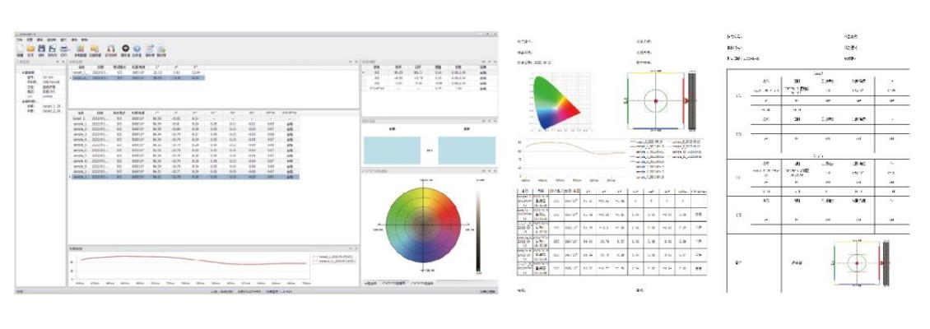

Ⅲ、Introduction to Appearance Structure

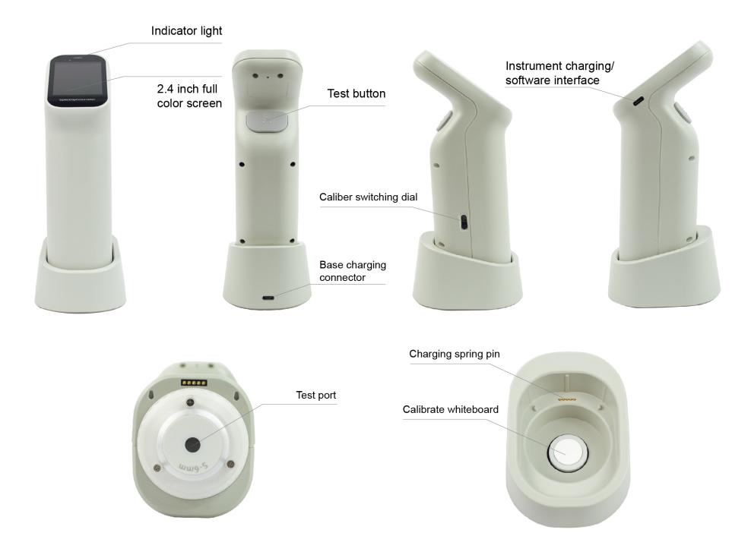

Ⅳ、Function difference

|  |  |  |  |
| --- | --- | --- | --- |
| Model | DS-200 | DS-210 | DS-220 |
| Test condition | SCI | SCI | SCI |
| Repeatability | ≤ 0.03 | ≤ 0.03 | ≤ 0.03 |
| Aperture | 2 | 4 | 6 |
| UV light source | × | × | √ |
| Camera function | × | √ | √ |
| Mobile App | √ | √ | √ |
| PC software | √ | √ | √ |

Ⅴ、Technical Parameter

|  |  |  |  |
| --- | --- | --- | --- |
| Product model | DS-200 | DS-210 | DS-220 |
| Measuring structure\* | D/8，SCI | | |
| Measurement  repeatability\*\* | ΔE\*ab≤ 0.03 | | |
| Display accuracy | 0.01 | | |
| Measuring  aperture | There are 2 stable and agile models in total:  Φ6mm，▽6mm | There are 4 stable and agile models in total:  Φ11mm，Φ6mm  ▽11mm，▽6mm | There are 6 stable and agile models in total:  Φ11mm，Φ6mm，Φ3mm  ▽11mm，▽6mm，▽3mm |
| Color Spaces  and Indices | Reflectance, CIE-Lab, CIE-LCh, HunterLab, CIE Luv, XYZ, Yxy, RGB, Color  difference(ΔE\*ab, ΔE\*cmc, ΔE\*94,ΔE\*00),WI(ASTM E313-00,ASTM E313-73,CIE,ISO2470/R457,  AATCC, Hunter, Taube Berger Stensby), YI(ASTM D1925,ASTM E313-00,  ASTM E313-73), Blackness(My,dM),Color Fastness | | |
| Source condition | A,B,C,D50,D55,D65,D75,F1,F2,F3,F4,F5,F6,F7,F8,F9,F10,F11,F12,CWF,U30,U35,DLF,NBF,TL83,  TL84,ID50,ID65,LED-B1,LED-B2,LED-B3,LED-B4,LED-B5,LED-BH1,LED-RGB1,LED-V1,LED-V2 | | |
| Light source | LED | | LED+UV |
| Measurement  observation method | Visual | Camera | |
| Calibration | Manual calibration | Auto calibration | |
| Software support | Andriod,iOS,Windows, Wechat app | | |
| Guaranteed accuracy | Guaranteed measurement | Guaranteed first class measurement | |
| Observer | 2°，10° | | |
| Integrating  sphere diameter | 40mm | | |
| Standards | CIE No.15,GB/T 3978,GB 2893,GB/T 18833,ISO7724-1,ASTM E1164,DIN5033 Teil7 | | |
| Ways of spectral | Nano-integrated spectral devices | | |
| Sensor | Silicon photodiode array Dual 16-group | | |
| Wavelength interval | 10nm | | |
| Wavelength range | 400-700nm | | |
| Reflectance determination range | 0-200% | | |
| Reflectance resolution | 0.01% | | |
| Measurement method | Single measurement, average measurement (2 to 99 measurements) | | |
| Measurement time | Approx. 1 second | | |
| Interface | USB， Bluetooth | | |
| Screen | Screen Full colour screen, 2.4 | | |
| Battery capacity | 8000 continuous measurements on a single charge, 3.7V/3000mAh | | |
| Life of light | 10 years and 1 million cycles | | |
| Language | Simplified Chinese, English | | |
| Storage | Instrument :10,000 data ; APP: mass storage | | |

\* Diffuse illumination / 8° directional reception with specular reflected light included / specular reflected light removed

\*\*White plate calibration with 30 standard deviations measured at 5 second intervals after white plate calibration

****Ⅳ**.Options**

|  |  |  |  |
| --- | --- | --- | --- |
| **The item code** |  | **Name** | **Picture** |
| 1.51.01.0076-0 |  | Powder measuring cassette | IMG_256 |
| 3.07.04.7006-0 |  | Powder measuring cassette - clear glass slides | IMG_256 |
| 1.51.02.0008-0 |  | Zhejiang Province modern metrology test measurement report | IMG_256 |
| 1.51.01.0016-0 |  | Ceramic panels | IMG_256 |
| 3.07.04.2003-0 |  | 800 quartz cylindrical cuvette (outer size φ32\*41mm, wall thickness 1.5mm) | IMG_256 |

**Ⅵ Company Profile**

**CHNSpec Technology (Zhejiang) Co., Ltd**

**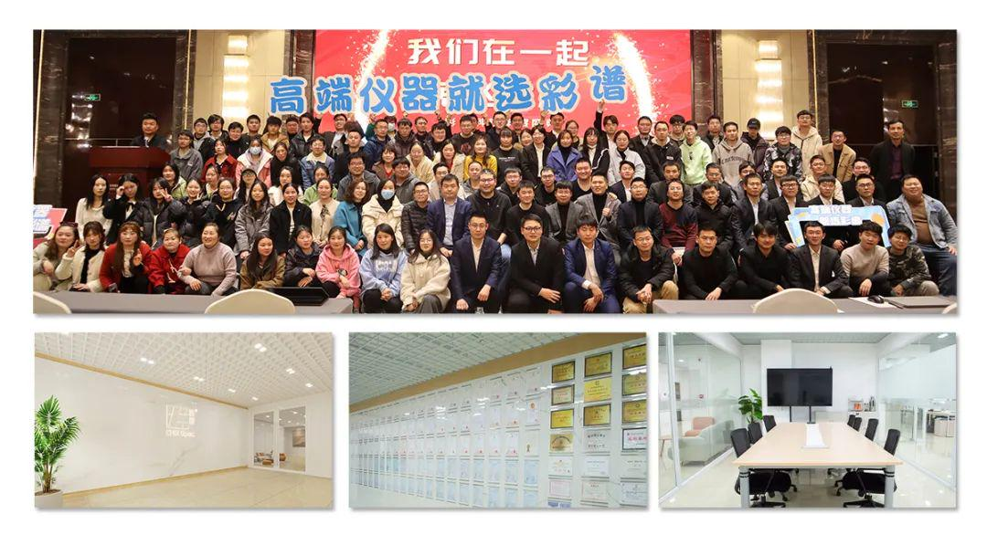**

CHNSpec Technology (Zhejiang) Co., Ltd. is a leading chinese enterprise in the field of color and appearance measure device, mainly engaged in the research and development, production, and sales of color detection equipment. the products include colorimeter, spectrophotometer, transmittance haze meters, gloss meter , paint color matching software, hyperspectral cameras, and are widely used in industries such as plastic, coatings, printing, automotive parts, metals, home appliances, universities, and research institutions both domestically and internationally. CHNSpec Technology (Zhejiang) Co., Ltd is located in Xiasha Higher Education Park, Hangzhou City. The main responsible person of the company has a senior professional title and a doctoral degree or above. The company has introduced R&D teams from well-known universities such as Zhejiang University and China Jiliang University. The development of color spectrum has attracted the attention of domestic experts and scholars, and has cooperative relationships with authoritative research institutions such as the Zhejiang Provincial Key Laboratory of Modern Metrology and Testing and Instruments, the National Engineering Center for Metrology and Testing Technology of the Ministry of Education, etc. With the care of various experts, the technical level and research and development capabilities of CHNSpec Technology (Zhejiang) Co., Ltd have achieved leapfrog development and achieved remarkable results. CHNSpec Technology (Zhejiang) Co., Ltd has a number of invention patents, including one American invention patent, a number of utility model patents, appearance patents, and software copyrights. In addition, multiple invention patents are still in the announcement stage. CHNSpec Technology (Zhejiang) Co., Ltd has published multiple papers in domestic first-class scientific research journals and has been included in SCI and EI.

**Qualifications and Honors  
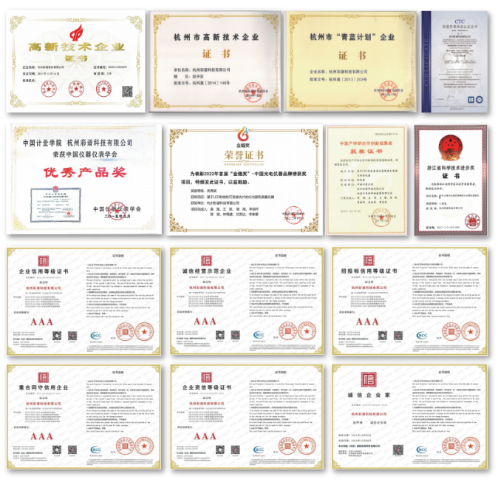**

**Patent technology  
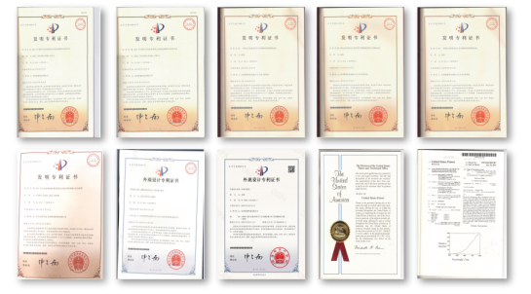**

**Product certificate  
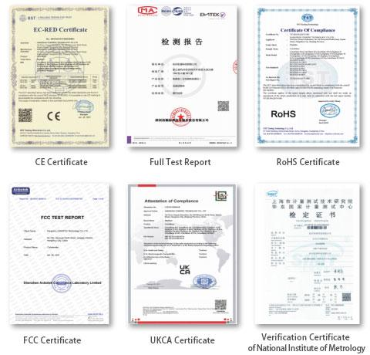**

**Participate in standard development  
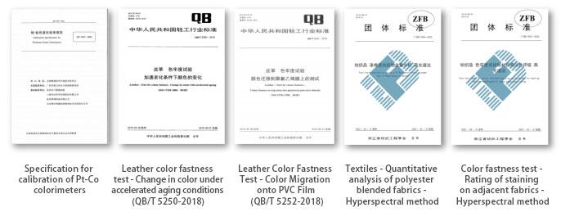**

**Industry conferences  
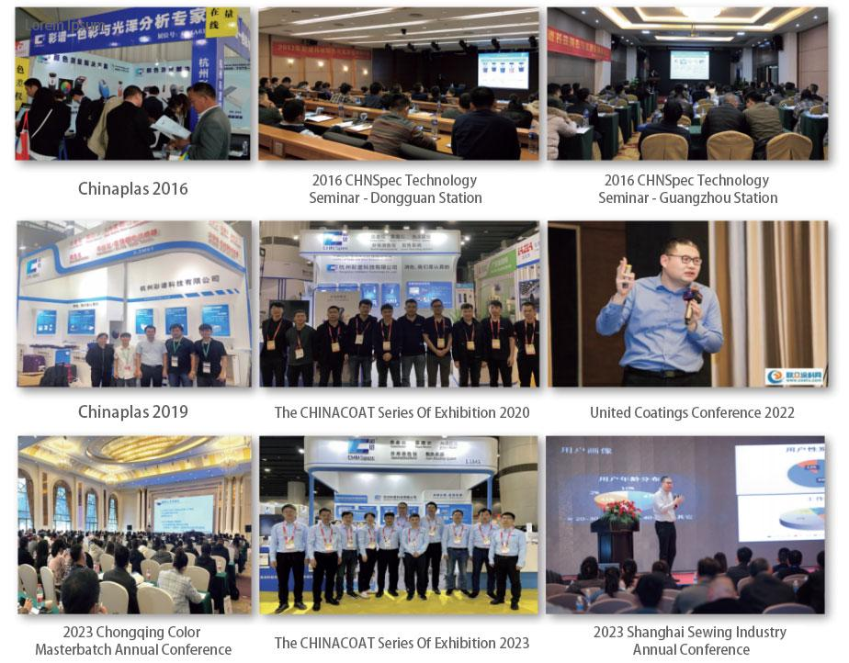**

**Partners**

**