**Color analysis instrument with excellent repetition accuracy**

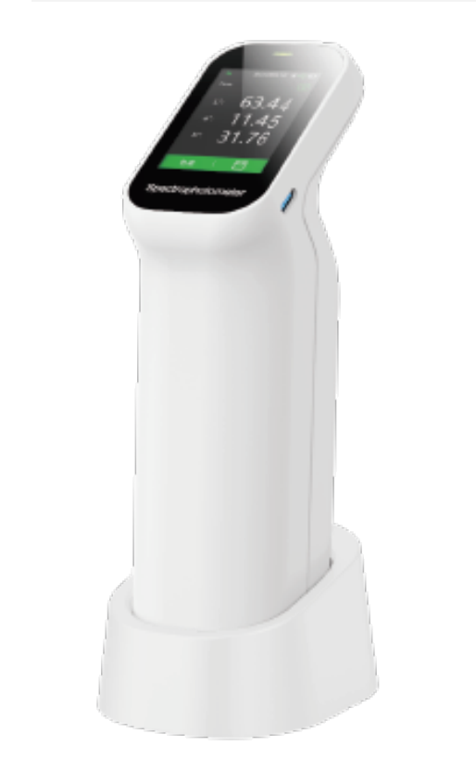

Stable repeatability and accuracy:dE\*ab≤0.03

1. **Core technology**
   1. Dual optical path design improves repeatability accuracy dE\*ab≤0.03

The dual optical path design monitors the energy fluctuations of the light source

while measuring the sample signal, reducing interference during measurement, achieving higher measurement stability, and improving the instrument's measurement repeatability index to dE \* ab ≤ 0.03. The measurement speed, accuracy, and stability of the instrument are ensured. Relevant technologies are protected by Chinese invention patents and American invention patents.

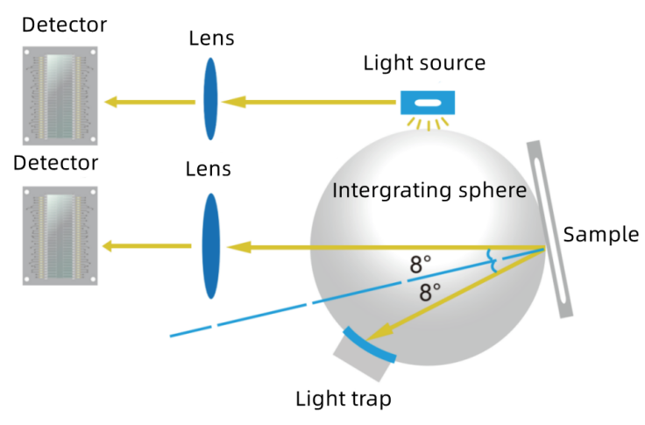

* 1. Innovative 5-micron thick nano integrated optics

Innovation is the soul of CHNspec. After nearly 10 years of dedicated research, using nano integrated optical devices as spectroscopic devices can achieve nano level spectroscopic capabilities with only 5 micron thick optical devices, once again leading the direction of industry innovation, greatly improving the technical performance of the product. Relevant technologies are protected by Chinese invention patents.

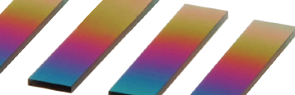

* Relevant technologies have been published in the famous Chinese optical academic journals "Journal of Optics" and "Journal of Photonics"

"Optimized Design of Spectroscopic Colorimeter Based on Real Time Dual Optical Path Correction"

"Design of a Color Measurement Instrument SCE Measurement Gloss Correction Model Based on D/8 Conditions"

* Relevant technologies are protected by Chinese invention patents:

Color measuring instrument and implementation method for correcting optical trap error based on D/8 conditions CN201310373360.1

Color Measurement Instrument and Implementation Method for Correcting Optical Trap Errors under D/8 Conditions CN201310373360.1

A Colorimeter Using Linear Variable Filter to Measure Object Color CN201310027285.3

* Relevant technologies are protected by US invention patents:

SPECTROPHOTOMETRIC COLORIMETER BASED ON LED LIGHT SOURCE AND METHOD FOR REALIZING THE SAME US9243953B1

* Relevant technologies have won the third prize of Zhejiang Provincial Science and Technology Progress Award and the Excellent Product Award of China Instrument and Meter Society

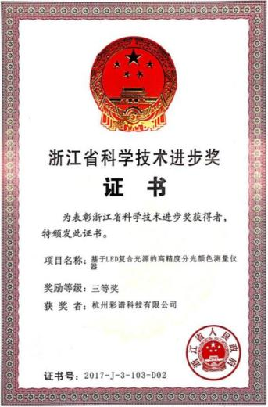 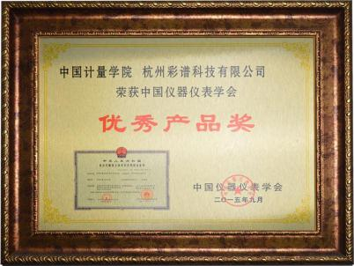 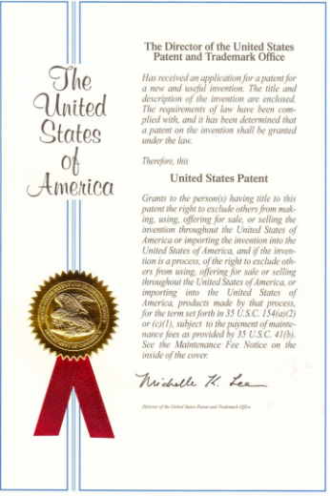

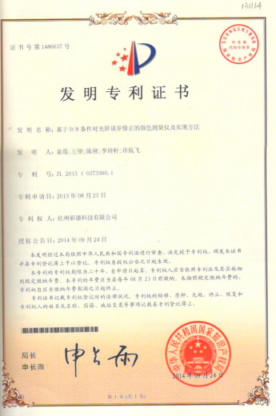 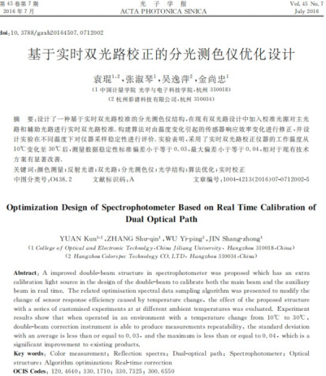 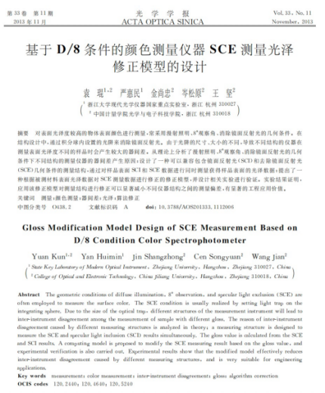

1. **Product characteristics**
   1. Ultra high repeatability accuracy:dE\*ab≤0.03

Repeatability accuracy is an important index to describe the accuracy of a spectrophotometer. The excellent photoelectric testing system scheme ensures that the repeatability and accuracy of the DS400 series spectrophotometer have reached a level unmatched by similar products.

The repeatability evaluation of the DS400 series spectrophotometer adopts strict standards, presenting excellent repeatability and accuracy performance.

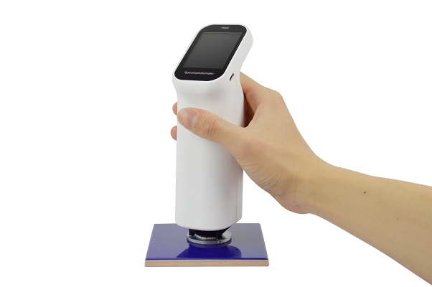

* 1. More than 30 measurement parameters
* RGB,Lab,Reflectance,LCh,Hunter Lab,CIE-Luv,XYZ,Yxy
* Color difference(ΔE\*ab,ΔE\*cmc,ΔE\*94,ΔE\*00)
* Whiteness(ASTM E313-00,ASTM E313-73,CIE/ISO,AATCC,Hunter,Taube Berger Stensby)
* Yellowness(ASTM D1925,ASTM E313-00,ASTM E313-73)
* Blackness(My,dM),Color Fastness,Tint(ASTM E313-00)
* Color Density CMYK(A,T,E,M),Milm,Munsell, Opacity, Color strength
  1. Evaluate whether the color jumps, providing nearly 40 evaluation light sources

A、 B, C, D50, D55, D65 and other nearly 40 kinds of evaluation light sources could be chosen, almost covering all the color measurement index and light types in the industry.

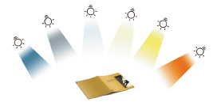

* 1. The base of the device was adjusted and the hardness of the Mo consortium was 9. The device's long-term stability was guaranteed

Compared with the existing products, there was no need to frequently adjust the DS400 series color difference instrument by hand when it was used. As long as it was placed on the base, the instrument would automatically adjust the overall function and accuracy of the instrument according to its own state and environment factors, making sure that the instrument was in a stable state and on standby at any time.

As for the existing products, there was no need for DS400 series to be tested frequently by hand when it was used. As long as it was placed on the base, the device would automatically adjust its overall function and accuracy according to its own state and environment factors, making sure that it was in a stable state and on standby at any time.

The white board in the base was the reference for the accuracy of the instrument. Through long-term investment and research, instrument has integrated zirconium material known as "artificial diamond" as a calibration whiteboard, with a surface Mohs hardness of 9. Because the material itself was as hard and stable as a diamond, it could guarantee that the surface of the board wouldn't be scratched, and it wouldn't change color with the change of temperature and humidity. Compared with the similar products both at home and abroad, the common industrial porcelain and even plastic were used as the white board for the reference. In this way, the stability and endurance of the equipment were further improved, and the performance of the equipment was guaranteed.

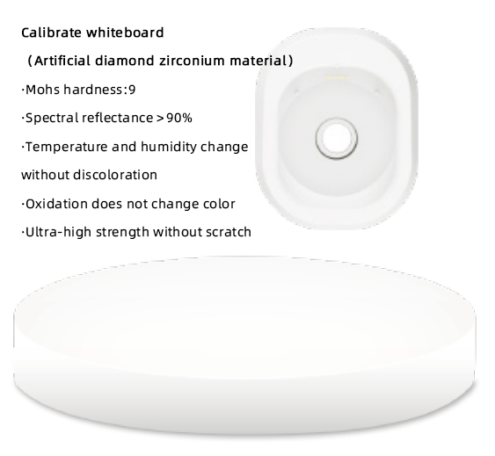

* 1. DS400 series could provide 10 different sizes of measurement

In order to make it convenient for the customer to measure the samples of different sizes, the DS400 series color contrast instrument could support 10 different sizes for the customer to use: stable:Φ11mm，Φ10mm，Φ6mm，Φ5mm，Φ3mm， dexterous: ▽11mm，▽10mm，▽6mm，▽5mm，▽3mm，which can be flexibly used in different use and testing conditions.

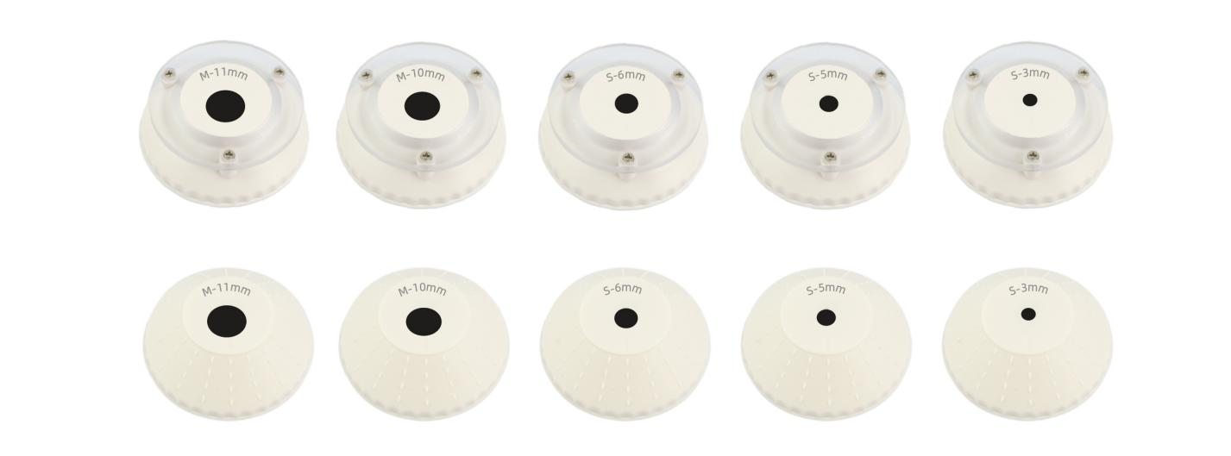

* 1. There was a high definition camera in the room, which could clearly observe the area being tested

DS400 series could get the image of the tested area through the camera when measuring. It could clearly locate the area where the sample was tested, so as to avoid the wrong area from being detected.

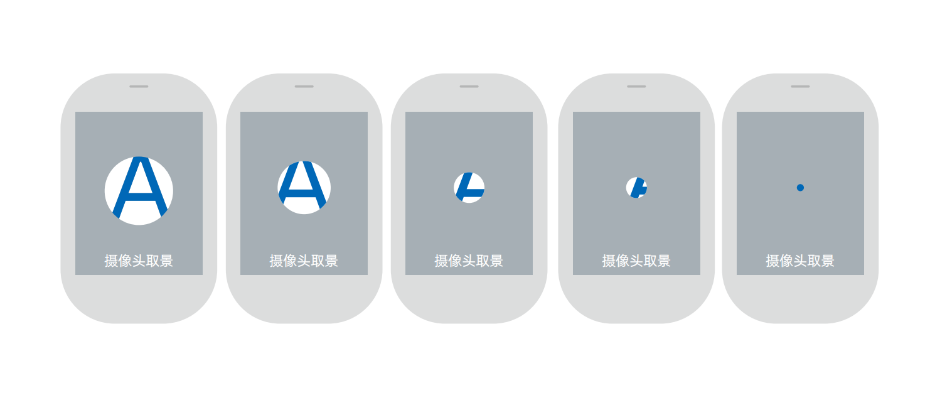

* 1. It also supported WeChat applications, such as Android, apple and omnipotent phone APP
* The DS400 series color detecting device could connect all kinds of mobile phones through rich mobile applications.
* The customer didn't need to send the sample color and object, and could easily send the color data through WeChat.
* The user could find the most similar color among several sets of color cards.
* The users could create a personal color database and enter information about printing, paint, spinning and other colors. The color library could be uploaded to the cloud, and many devices could share data, so that color processing was more convenient.
* Enterprises could establish and manage their own color card information library and color formulas in the cloud, and share them with their own users through unique invitation cards.



Mobile APP

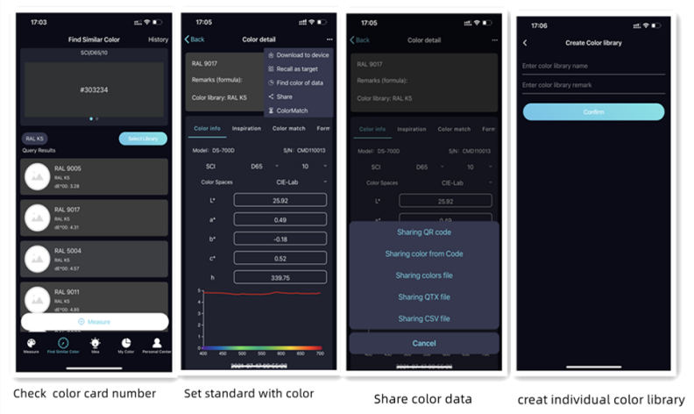

* 1. Using the powerful color management system ColorExpert on PC\*

The Windows color management system ColorExpert was attached to the DS400 series. It was connected to the DS400 series through Bluetooth or USB.

ColorExpert was a color management software with four functions: my color, color detection, color system and personal center.

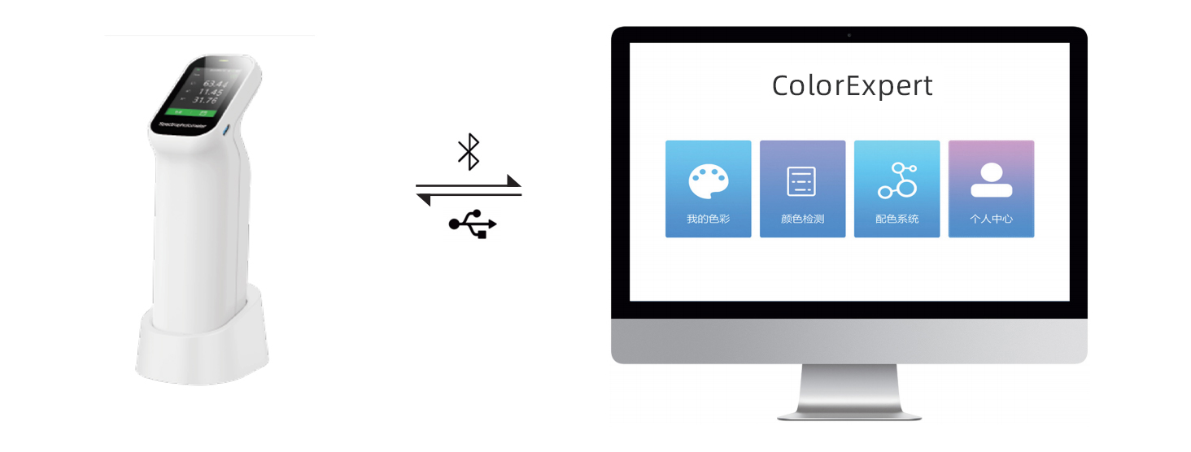

In the "my color" function, the user could collect or build the color library he or she needed in hundreds of other colors which were shared by themselves. The PC software and the mobile APP could share the same account, and the data of the color library could follow the account, so that the information of the computer and the mobile could be in sync.

In the "color detecting" function, the user could use the computer software to adjust, measure and set up a light detecting device. The users could use the colors in the cloud data bank as samples to test the color difference, and check the color difference picture, the color difference picture, the data of the standard samples, and the test report of the data they wanted.

In the color system, it could provide a more convenient and efficient color matching process for the users. After measuring the color of the sample with the instrument, the system calculated the formula in the formula center and adjusted the color automatically, and finally achieved an accurate match. It was suitable for computer automatic color matching in paint, paint, printing, spinning and other fields.

In the "personal center", the user could edit his own personal information, search or delete the connected instrument information, manage the downstream users, and manage the color library that was shared with the downstream users.

1. **Introduction to the exterior structure**

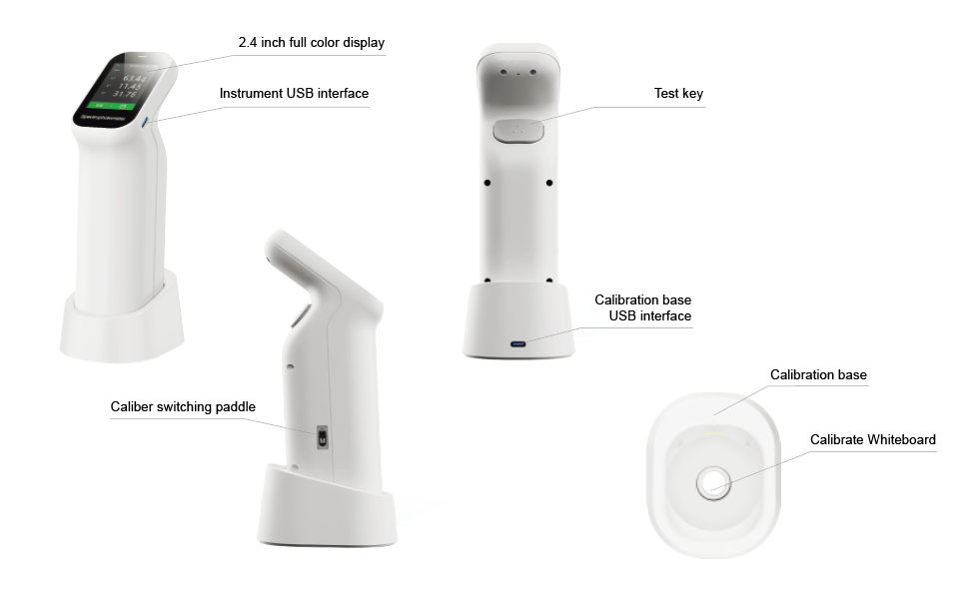

1. **Model Function Summary**

|  |  |  |  |
| --- | --- | --- | --- |
| Model | DS-400 | DS-410 | DS-420 |
| Measurement conditions | SCI+SCE | SCI+SCE | SCI+SCE |
| Repeatability | ≤0.03 | ≤0.03 | ≤0.03 |
| Caliber | Four types | Six kinds | Ten types |
| Include UV light source | × | × | √ |
| Camera | × | √ | √ |
| Mobile APP | √ | √ | √ |
| pc software | √ | √ | √ |

**5.Technical Data**

|  |  |  |  |
| --- | --- | --- | --- |
| Name | DS-400 | DS-410 | DS-420 |
| Geometry\* | D/8,SCI+SCE | | |
| Repeatability\*\* | dE\*ab≤0.03 | | |
| Display Resolution | 0.01 | | |
| Measuring aperture | 2 w/ plate and 2 w/o plate：  Φ11mm，Φ6mm  ▽11mm，▽6mm | 3 w/ plate and 3 w/o plate：  Φ11mm，Φ6mm，Φ3mm  ▽11mm，▽6mm，▽3mm | 5 w/ plate and 5 w/o plate：  Φ11mm，Φ10mm，Φ6mm，Φ5mm，Φ3mm  ▽11mm，▽10mm，▽6mm，▽5mm，▽3mm |
| Measurement  index | Reflectance,CIE-Lab,CIE-LCh,HunterLab,CIE-Luv,XYZ,Yxy,RGB,Color difference(ΔE\*ab,ΔE\*cmc,ΔE\*94,ΔE\*00),WI(ASTME313-00,ASTM E313-73,CIE,ISO2470/R457,,AATCC,Hunter,  TaubeBergerStensby),  YI(ASTM D1925,ASTM E313-00,ASTM E313-73),Blackness（My,dM）,  Color Fastness, Tint,(ASTM E313-00),Color Density CMYK(A,T,E,M),Milm, Munsell,  Opacity, Color strength | | |
| Illuminants | A,B,C,D50,D55,D65,D75,F1,F2,F3,F4,F5,F6,F7,F8,F9,F10,F11,F12,CWF,U30,U35,DLF,NBF,TL83,TL84,ID50,ID65,LED-B1,LED-B2,LED-B3,LED-B4,LED-B5,LED-BH1,LED-RGB1,LED-V1, LED-V2 | | |
| Light Source | Full-band balancedLED light source | | Full-band balancedLED light source+UV |
| Observer Angles | 2°，10° | | |
| Sphere Size | 40mm | | |
| Standards | CIE No.15,GB/T 3978,GB 2893,GB/T 18833,ISO7724-1,ASTM E1164,DIN5033 Teil7 | | |
| Spectroscopic method | Nanometer integrated spectral device | | |
| Sensor | Silicon photodiode array double 16 groups | | |
| Wavelength Interval | 10nm | | |
| Wavelength Range | 400-700nm（Users can view the reflectivity of 31 wavelengths） | | |
| Reflectance Range | 0-200% | | |
| Reflectivity resolution | 0.01% | | |
| Measurement method | Single measurement, average measurement (2~99 times) | | |
| Measurement time | About 1 second | | |
| Measurement and  observation mode | Visual | Camera | |
| Calibration | Intelligent automatic calibration | | |
| Software support | Andriod,iOS,Windows,WeChat applet | | |
| Accuracy | Qualified measurement | Metrology Level I | |
| Interface | USB，Bluetooth | | |
| Screen | Full Color Screen,2.4 inches | | |
| Battery capacity | Rechargeable, 8000 times continuous tests， 3.7V/3000mAh | | |
| Light Source Lifetime | 10 years, 1 million tests | | |
| Language | Chinese and English | | |
| Storage | Instrument: 10000 pieces of data; APP: mass storage | | |

\*45 degree circular illumination/0 degree angle reception

\*\*When a white tile is measured 30 times at 5-seconds interval with MAV

The parameters are subject to change without notice

6.Options

|  |  |  |  |
| --- | --- | --- | --- |
| **The item code** |  | **Name** | **Picture** |
| 1.51.01.0076-0 |  | Powder measuring cassette | IMG_256 |
| 3.07.04.7006-0 |  | Powder measuring cassette - clear glass slides | IMG_256 |
| 1.51.02.0008-0 |  | Zhejiang Province modern metrology test measurement report | IMG_256 |
| 1.51.01.0016-0 |  | Ceramic panels | IMG_256 |
| 3.07.04.2003-0 |  | 800 quartz cylindrical cuvette (outer size φ32\*41mm, wall thickness 1.5mm) | IMG_256 |

**7.Company Profile**

**CHNSpec Technology (Zhejiang) Co., Ltd**

**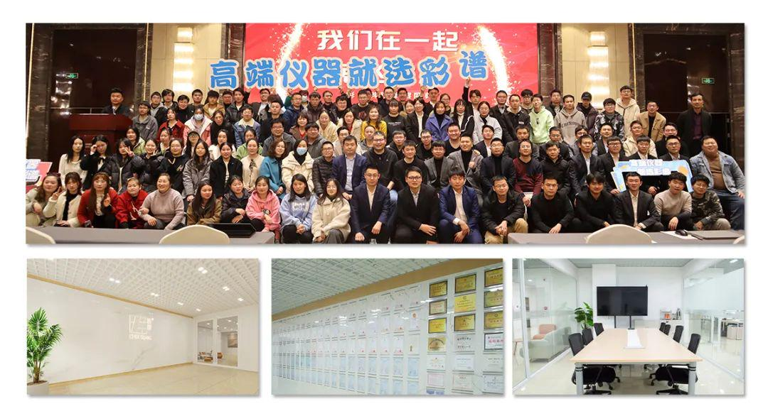**

CHNSpec Technology (Zhejiang) Co., Ltd. is a leading chinese enterprise in the field of color and appearance measure device, mainly engaged in the research and development, production, and sales of color detection equipment. the products include colorimeter, spectrophotometer, transmittance haze meters, gloss meter , paint color matching software, hyperspectral cameras, and are widely used in industries such as plastic, coatings, printing, automotive parts, metals, home appliances, universities, and research institutions both domestically and internationally. CHNSpec Technology (Zhejiang) Co., Ltd is located in Xiasha Higher Education Park, Hangzhou City. The main responsible person of the company has a senior professional title and a doctoral degree or above. The company has introduced R&D teams from well-known universities such as Zhejiang University and China Jiliang University. The development of color spectrum has attracted the attention of domestic experts and scholars, and has cooperative relationships with authoritative research institutions such as the Zhejiang Provincial Key Laboratory of Modern Metrology and Testing and Instruments, the National Engineering Center for Metrology and Testing Technology of the Ministry of Education, etc. With the care of various experts, the technical level and research and development capabilities of CHNSpec Technology (Zhejiang) Co., Ltd have achieved leapfrog development and achieved remarkable results. CHNSpec Technology (Zhejiang) Co., Ltd has a number of invention patents, including one American invention patent, a number of utility model patents, appearance patents, and software copyrights. In addition, multiple invention patents are still in the announcement stage. CHNSpec Technology (Zhejiang) Co., Ltd has published multiple papers in domestic first-class scientific research journals and has been included in SCI and EI.

**Qualifications and Honors  
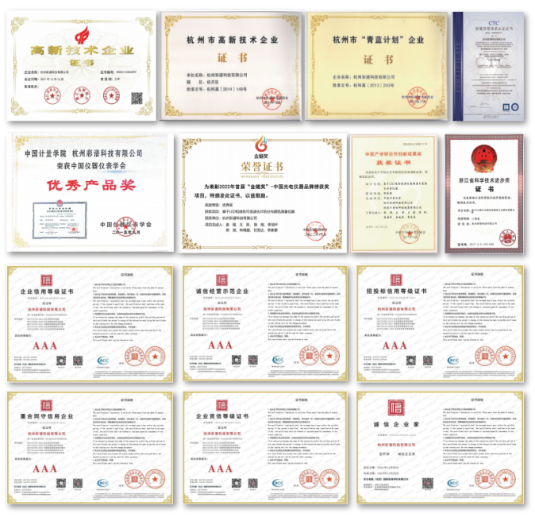**

**Patent technology  
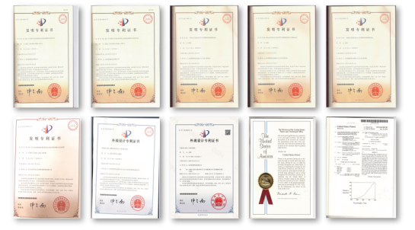**

**Product certificate  
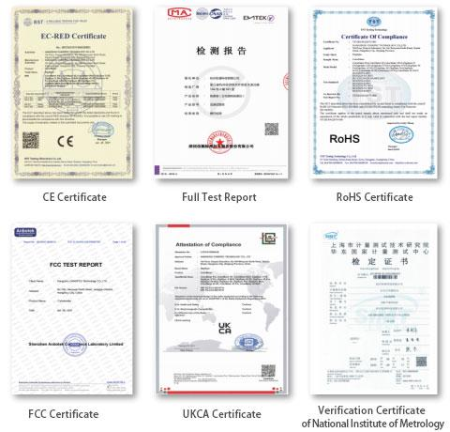**

**Participate in standard development  
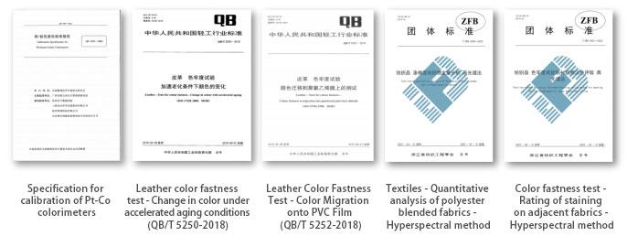**

**Industry conferences  
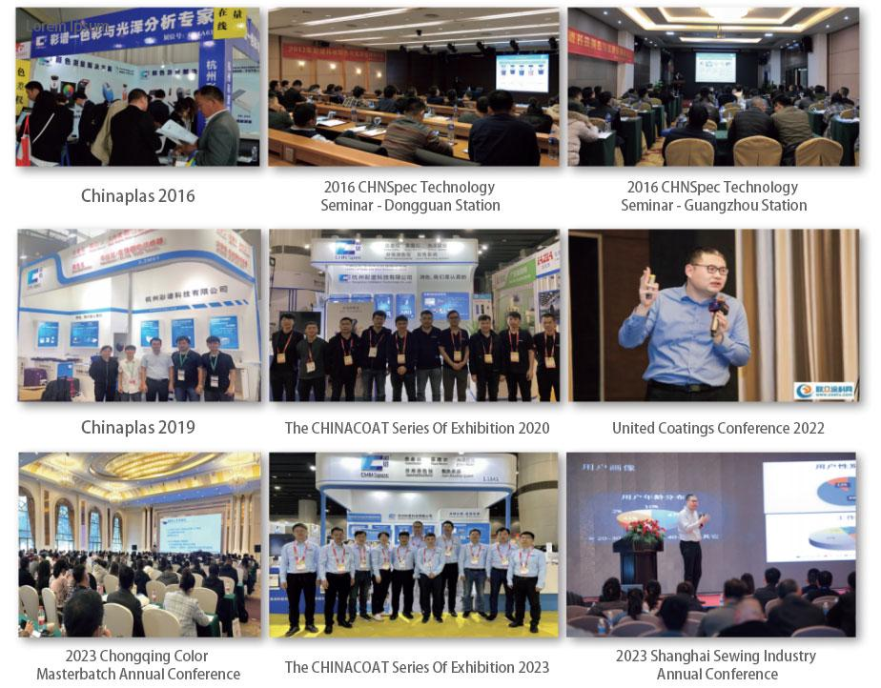**

**Partners**

**