

**DC-23D**

**DC-25D**

**DC-26D**

**High precision Portable spectrophotometer**

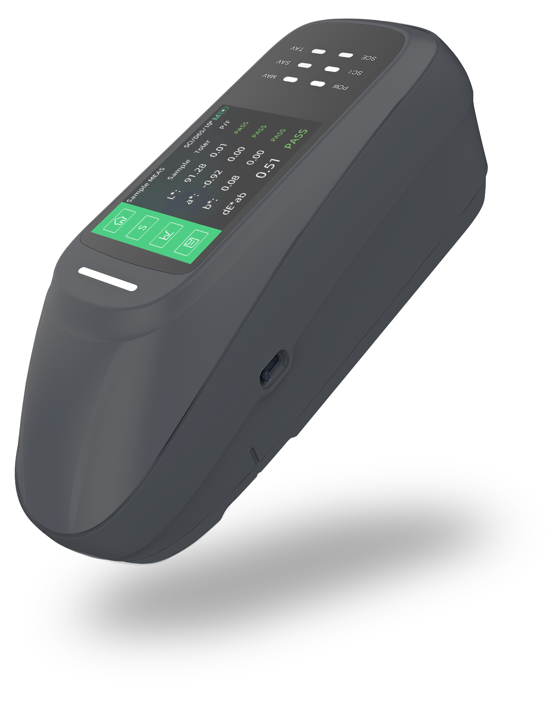

**Repeatability Accuracy dE\*ab≤0.01**

**Inter-Instrument Agreement dE\*ab≤0.12**

1. 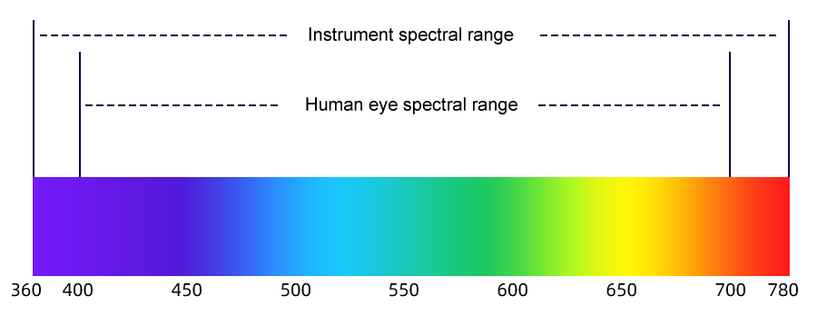**Product features**

* **Industry-leading wavelength range:**

**360-780nm**

* The wavelength range of conventional

colorimeter is 400-700nm. In order to achieve moreAdd precise color measurement and extend the wavelength to 360-780nm

**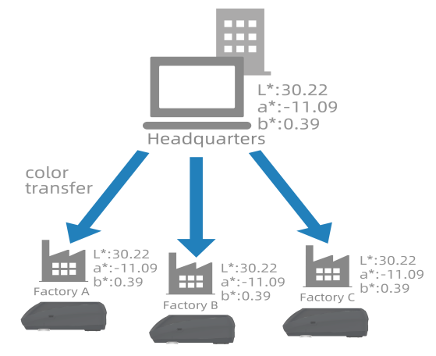**

* **Outstanding stage-to-stage variation and repeatability**
* The inter-stage difference is 0.12, which helps improve

the color quality between manufacturers and suppliers

* The repeatability is 50% higher than the previous

generation, reaching 0.01

**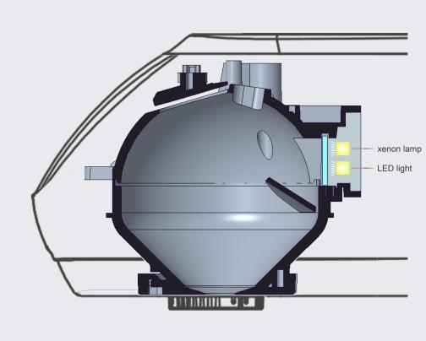**

* **Dual light source system provides longer service life than expected**
* Use xenon lamp and LED to provide sufficient

ultraviolet and visible light at the same time

energy and ensure a measurement life of tens of millions of times

* **Support NetProf network correction function**
* Using NetProf software, the measurement

performance of the instrument can be regularly checkedto ensure accurate and reliable color measurement Calibration can reduce the risk of instrument failure caused by component aging, wear, etc.System deviation caused by the system deviation, accurate measurement data brings users more freedom Xin usage experience

****

**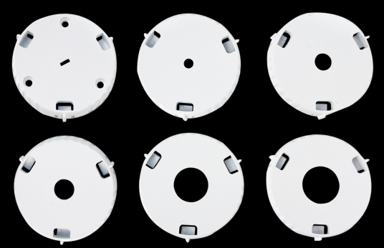**

* **Provides 6 measuring apertures to easily measure samples of different shapes**
* Six hole specifications: 11mm, 10mm, 6mm, 5mm,

3mm, 1\*3mm diameter, very small objects or curved surface samples can also be easily measured

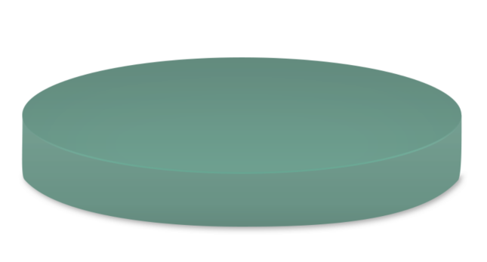

* **BCRA green plate wavelength calibration**
* Automatic wavelength accuracy calibration using

reference grade BCRA green plate correct to ensure that the instrument is consistent

**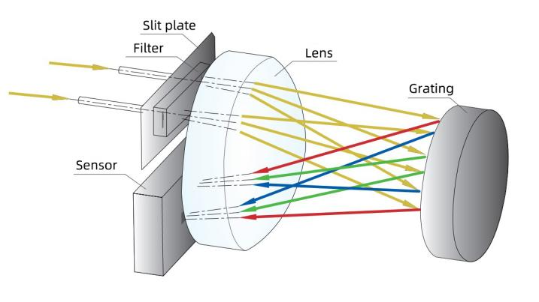**

* **Indication accuracy increased by 60%**
* Using a new generation of array silicon light

sensor, the amount of light input is increased

65%, spectral resolution increased by 39%, compared with the previous generation The indication accuracy is increased by 60%

* **Intelligent automatic calibration**
* Frequent manual calibration is not required

during use, as long as the calibration On the accurate base, the instrument will automatically adjust according to its own status and environmental factors.Calibrate the overall instrument function and accuracy to ensure that the instrument The device is always in a stable state and ready for use at any

**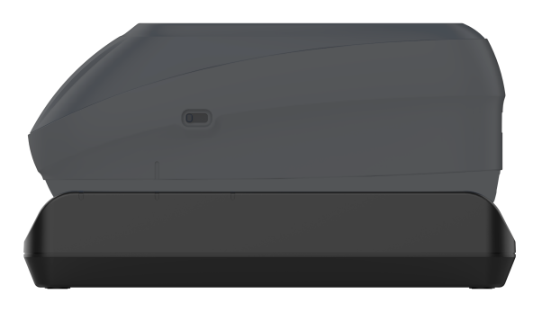**

1. **Brief table of model differences**

|  |  |  |  |
| --- | --- | --- | --- |
| **model** | **Spectrophotometer DC-23D** | **Spectrophotometer DC-25D** | **Spectrophotometer DC-26D** |
| SCI | ● | ● | ● |
| SCE | ● | ● | ● |
| Measurement repeatability | dE\*ab≤0.02 | dE\*ab≤0.01 | |
| Inter-Instrument Agreement | dE\*ab≤0.25 | dE\*ab≤0.2 | dE\*ab≤0.12 |
| caliber | Φ11mm,Φ6mm | Φ11mm,Φ10mm,  Φ6mm,Φ3mm | Φ11mm,Φ10mm,  Φ6mm,Φ5mm,Φ3mm,  1mm\*3mm |
| Wavelength range | 360-740nm | 360-780nm | |
| Light source life | 6 million times | 10 million times | |
| UV | ● | ● | ● |
| measurement observation method | Camera | Camera | Camera |
| BCRA Green Brick | ● | ● | ● |
| NetProf network calibration | ● | ● | ● |

1. **Product parameters**

|  |  |  |  |
| --- | --- | --- | --- |
| **Product model** | **Spectrophotometer DC-23D** | **Spectrophotometer DC-25D** | **Spectrophotometer DC-26D** |
| Measuring structure**※** | D/8,SCI+SCE | | |
| Light source life | 6 million times | 10 million times | |
| Wavelength range | 360-740nm | 360-780nm | |
| SCI+SCE Measure simultaneously | support | | |
| NetProf network calibration | support | | |
| Calibration method | BCRA certified black and white board energy calibration,  green board wavelength accuracy calibration | | |
| Measurement repeatability**※※** | dE\*ab≤0.02 | dE\*ab≤0.01 | |
| Inter-Instrument agreement※※※ | dE\*ab≤0.25 | dE\*ab≤0.2 | dE\*ab≤0.12 |
| Display accuracy | 0.01 | | |
| Lighting source | Full-band balanced LED light source + xenon lamp | | |
| UV light source | Yes | | |
| Caliber | Φ11mm,Φ6mm | Φ11mm,Φ10mm,  Φ6mm,Φ3mm | Φ11mm,Φ10mm,Φ6mm,5mm,Φ3mm,1mm\*3mm |
| Measurement standard | Spectral reflectance, CIE-Lab, CIE-LCh, HunterLab, CIE-Luv, XYZ, Yxy, RGB color difference (ΔE\*ab, ΔE\*cmc, ΔE\*94, ΔE\*00), whiteness (ASTM E313-00, ASTM E313-73, CIE, ISO2470/R457, AATCC, Hunter, Taube Berger Stensby), yellowness (ASTM D1925, ASTM E313-00, ASTM E313-73) blackness (My, dM), stain fastness, discoloration Fastness, Tint (ASTM E313-00) color density CMYK (A, T, E, M), metamerism index Milm, Munsell, hiding power, strength (dye strength, tinting strength) | | |
| Light source conditions | A,B,C,D50,D55,D65,D75F1,F2,F3,F4,F5,F6,F7,F8,F9,F10,F11,F12CWF,U30,U35,DLF,NBF,TL83,TL84,ID50,ID65,LED-B1,LED-B2,LED-B3,LED-B4LED-B5,LED-BH1,LED-RGB1,LED-V1,LED-V2 | | |
| Observation method | Camera | | |
| Calibration | Intelligent automatic calibration | | |
| Software support | Android, iOS, Windows, WeChat applet | | |
| Accuracy guaranteed | Guarantee first-level measurement qualification | | |
| Standard observer | 2°，10° | | |
| Integrating sphere diameter | 40mm | | |
| Standards | CIE No.15,GB/T 3978,GB 2893,GB/T 18833,ISO7724-1,ASTM E1164,DIN5033 Teil7 | | |
| Spectral method | grating | | |
| Sensor | Dual column high-precision CMOS array sensor | | |
| Wavelength interval | 10nm | | |
| Reflectivity measurement range | 0-200% | | |
| Reflectance resolution | 0.01% | | |
| Measuring time | about 1 second | | |
| Interface | USB, Bluetooth | | |
| Screen | Full color screen, 3.5 inches | | |
| Battery capacity | Can continuously measure 8000 times on a single charge, 7.2V/3000mAh | | |
| Language | Simplified Chinese, English | | |
| Storage | Instrument: 10,000 items; APP: Mass storage | | |
| Size | 233mm\*77mm\*93mm | | |
| Weight  ※ Diffuse lighting/8° direction reception, including specular reflected light/removing specular reflected light  ※※ After the whiteboard is calibrated, measure the whiteboard 30 times at 5-second intervals. Standard deviation of the MAV caliber measurement results.  ※※※ The average of the MAV caliber measurement values of 12 color plates in the BCRA series. | About 600g | | |

|  |
| --- |
|  |

|  |
| --- |
|  |

1. **Optional accessories**

|  |  |  |
| --- | --- | --- |
| **Material code** | **Name** | **Picture** |
| 1.51.01.0069-0 | 12 colored bricks | 12色砖 |
| 1.51.01.0068-0 | 24 colored bricks | 24色转 |
| 1.51.02.0008-0 | Zhejiang Province Modern Metrology Test Measurement Report | IMG_256 |
| 1.51.01.0016-0 | Ceramic test base plate | IMG_256 |
| 3.07.04.2003-0 | 800 quartz cylindrical cuvette (outer size φ32\*41mm, wall thickness 1.5mm) | IMG_256 |



**CHNSpec Technology (Zhejiang) Co., Ltd**

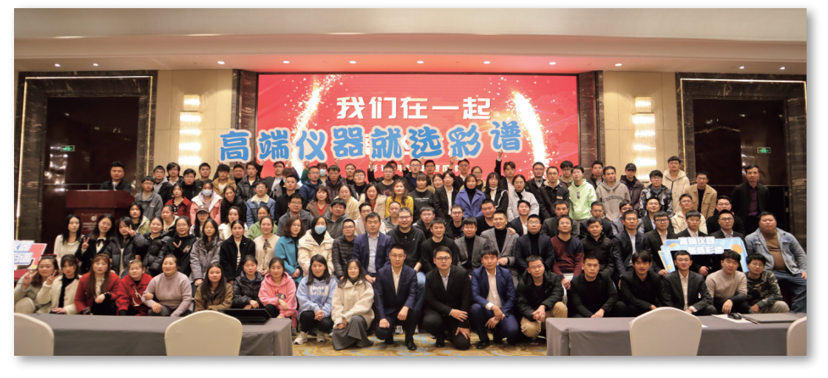

CHNSpec Technology (Zhejiang) Co., Ltd is a domestic leading enterprise in the field of color detection, mainly engaged in the research and development, production and sales of color detection equipment, products including color difference meter, spectrophotometer, transmittance fog meter, gloss meter, paint color matching software, hyperspectral camera, in domestic and foreign plastics, paint, printing, auto parts, metal, home appliances and other industries, universities, scientific research institutions are widely used. Color spectrum Technology is located in Xiasha Higher Education Park, Hangzhou. The principal person in charge of the company has a senior title and a doctorate degree or above. The company has introduced research and development teams from well-known universities such as Zhejiang University and China Jiliang University. The development of color spectrum has attracted the attention of domestic experts and scholars, and has cooperated with authoritative research institutions such as the Key Laboratory of Modern Metrology Testing and Instrumentation of Zhejiang Province and the National Engineering Center of Metrology Testing Technology of the Ministry of Education. Under the care of experts, the technical level and research and development ability of color spectrum have been developed by leaps and bounds, and have achieved remarkable results. Color spectrum technology has a number of invention patents, including the United States invention patent 1, a number of utility model patents, appearance patents, software Copyrights. In addition, there are a number of invention patents in the announcement stage. Many papers published by color spectrum technology were published in domestic first-class scientific research journals, and were included by SCI and EI.

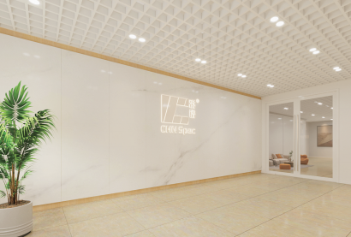

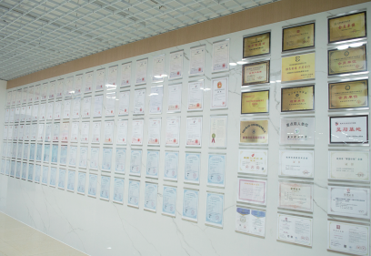

CHNSpec Technology (Zhejiang）Co.,Ltd



CHNSpec Technology (Zhejiang）Co.,Ltd

**Qualification and honor**

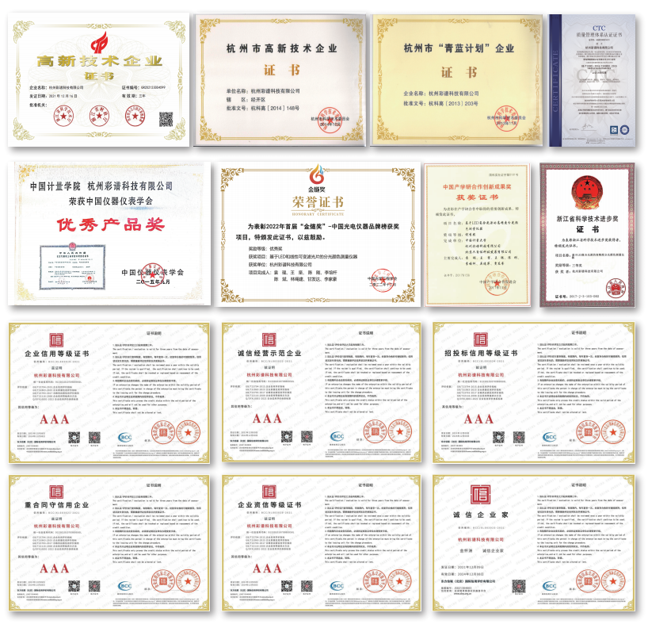

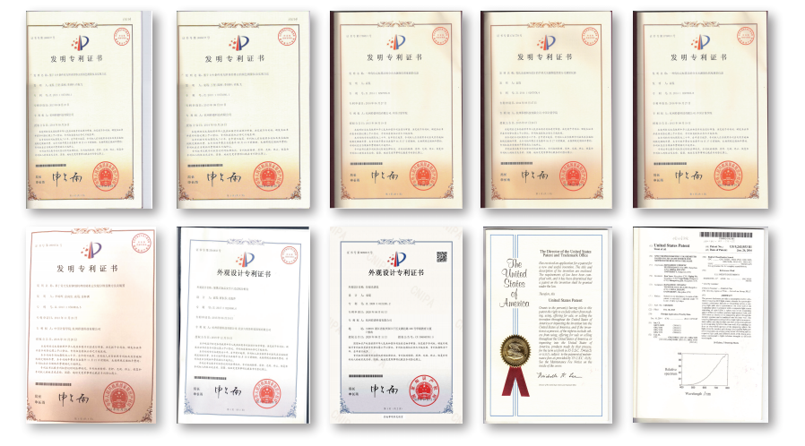



CHNSpec Technology (Zhejiang）Co.,Ltd

**Product certificate**

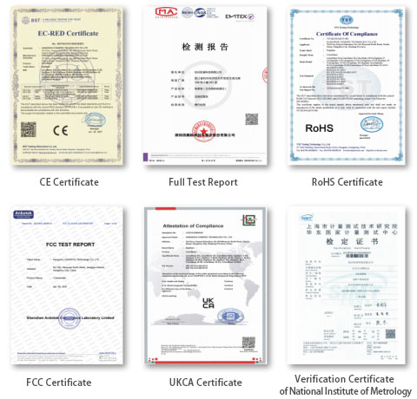

CHNSpec Technology (Zhejiang）Co.,Ltd

**Participation in standard development**

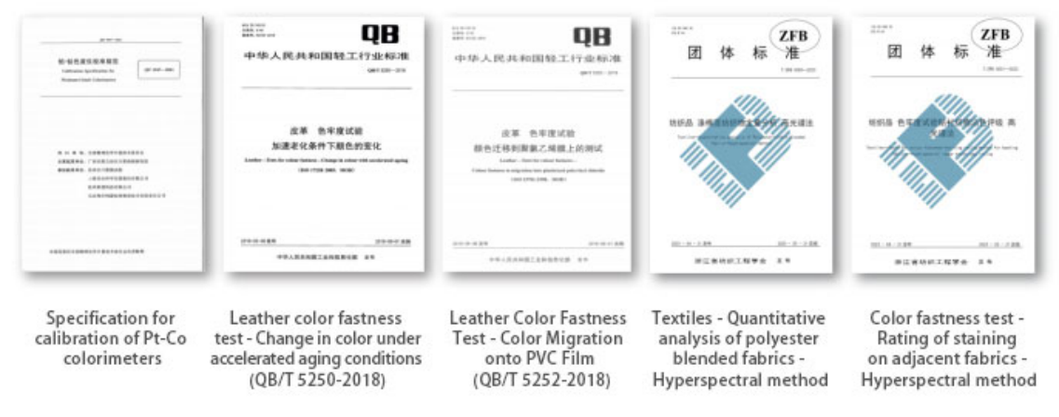

**Industry conference**

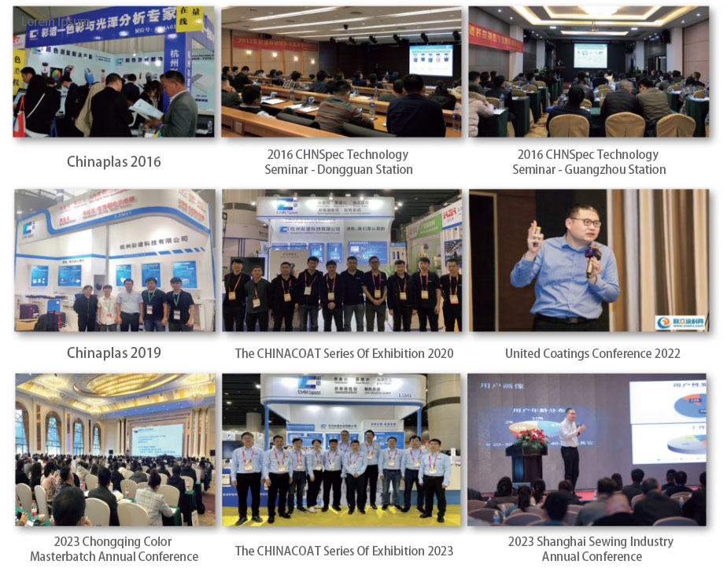

CHNSpec Technology (Zhejiang）Co.,Ltd